**VISVESVARAYA TECHNOLOGICAL UNIVERSITY**

**“JnanaSangama”, Belgaum -590014, Karnataka.**



**LAB REPORT**

**on**

**Object Oriented Java Programming (23CS3PCOOJ)**

***Submitted by***

**Darshan YG (1BM23CS087)**

***in partial fulfillment for the award of the degree of***

**BACHELOR OF ENGINEERING**

***in***

**COMPUTER SCIENCE AND ENGINEERING**



**B.M.S. COLLEGE OF ENGINEERING**

**(Autonomous Institution under VTU)**

**BENGALURU-560019**

**Sep-2024 to Jan-2025**

**B.M.S. College of Engineering,**

**Bull Temple Road, Bangalore 560019**

(Affiliated To Visvesvaraya Technological University, Belgaum)

**Department of Computer Science and Engineering**



**CERTIFICATE**

This is to certify that the Lab work entitled “Object Oriented Java Programming (23CS3PCOOJ)” carried out by **Darshan YG (1BM23CS087),** who is bonafide student of **B.M.S. College of Engineering.** It is in partial fulfillment for the award of **Bachelor of Engineering in Computer Science and Engineering** of the Visvesvaraya Technological University, Belgaum. The Lab report has been approved as it satisfies the academic requirements in respect of an Object Oriented Java Programming (23CS3PCOOJ) work prescribed for the said degree.

|  |  |
| --- | --- |
| Swathi Sridharan  Assistant Professor  Department of CSE, BMSCE | Dr. Jyothi S Nayak  Professor & HOD  Department of CSE, BMSCE |

**Index**

|  |  |  |  |
| --- | --- | --- | --- |
| **Sl.**  **No.** | **Date** | **Experiment Title** | **Page No.** |
| 1 | **01/10/2024** | **Roots of a Quadratic equation** | **4-7** |
| 2 | **08/10/2024** | **Calculating SGPA** | **7-15** |
| 3 | **15/10/2024** | **Book Details** | **16-22** |
| 4 | **22/10/2024** | **Abstract Class Animals** | **23-27** |
| 5 | **29/10/2024** | **Bank details** | **27-39** |
| 6 | **12/11/2024** | **Packages** | **39-46** |
| 7 | **19/11/2024** | **Interface** | **46-50** |
| 8 | **26/11/2024** | **Exception Handling** | **50-55** |
| 9 | **03/12/2024** | **Threads** | **55-59** |
| 10 | **03/12/2024** | **GUI – Java Swing** | **60-64** |

Github Link: https://github.com/DarshanYG/OOJ_Lab

**Program 1**

Implement Quadratic Equation

Algorithm:

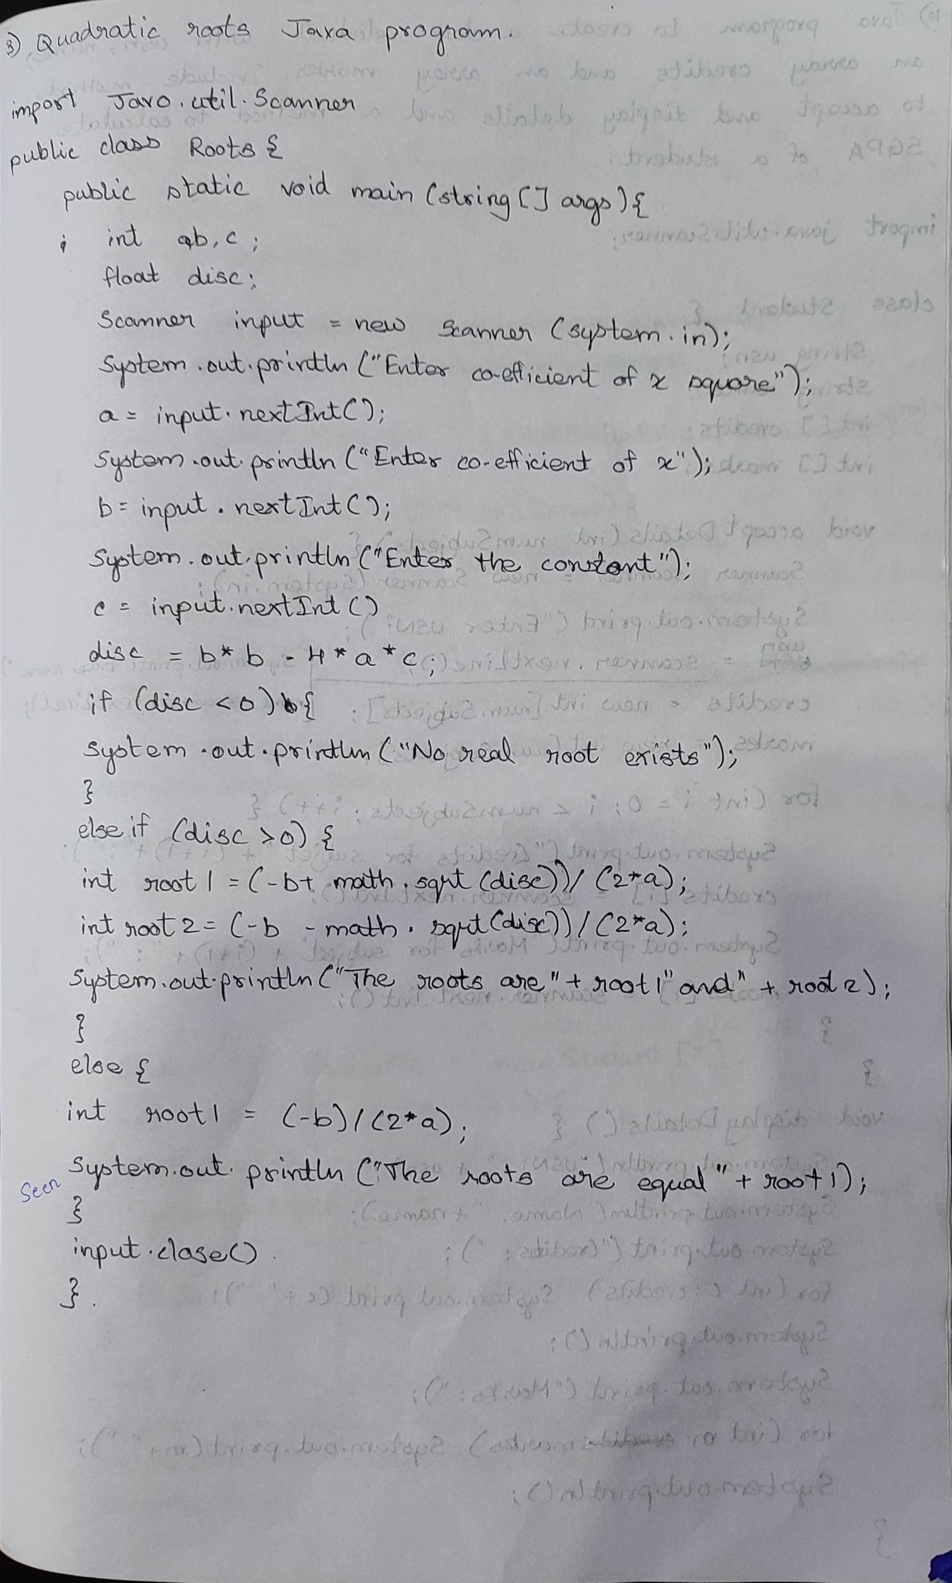

Code:

import java.util.Scanner;

public class Roots {

public static void main(String[] args) {

System.out.println("Darshan YG, 1BM23CS087");

int a, b, c;

float disc;

Scanner input = new Scanner(System.in);

System.out.println("Enter coefficient of x square:");

a = input.nextInt();

System.out.println("Enter co-efficient of x:");

b = input.nextInt();

System.out.println("Enter the constant:");

c = input.nextInt();

disc = b * b - 4 * a * c;

if (disc < 0) {

System.out.println("No real roots exist");

}

else if (disc > 0) {

int root1 = (-b + (int)Math.sqrt(disc)) / (2 * a);

int root2 = (-b - (int)Math.sqrt(disc)) / (2 * a);

System.out.println("The roots are " + root1 + " and " + root2);

}

else {

int root1 = (-b) / (2 * a);

System.out.println("The roots are equal: " + root1);

}

input.close();

}

}

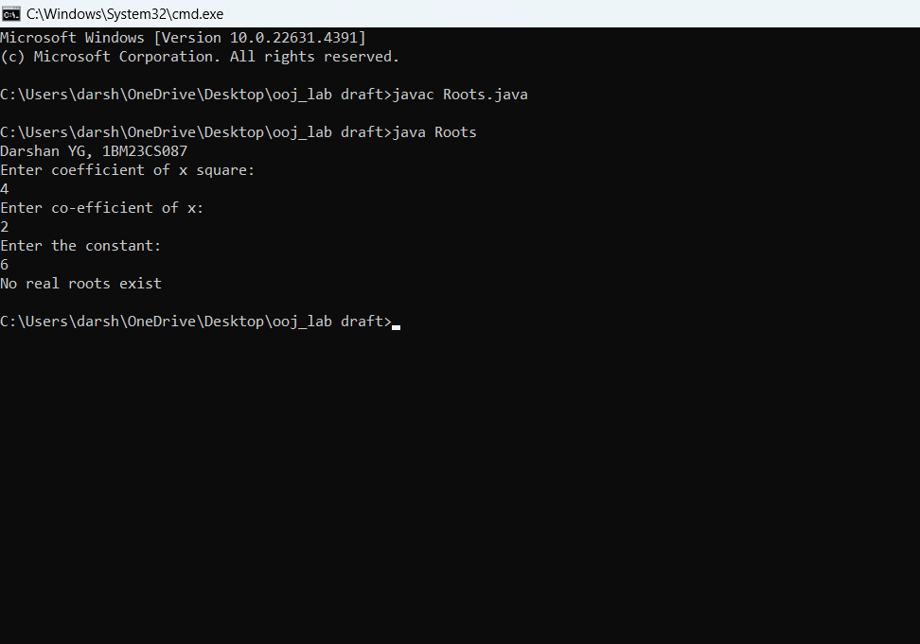

**Program 2**

Calculating SGPA

Algorithm:

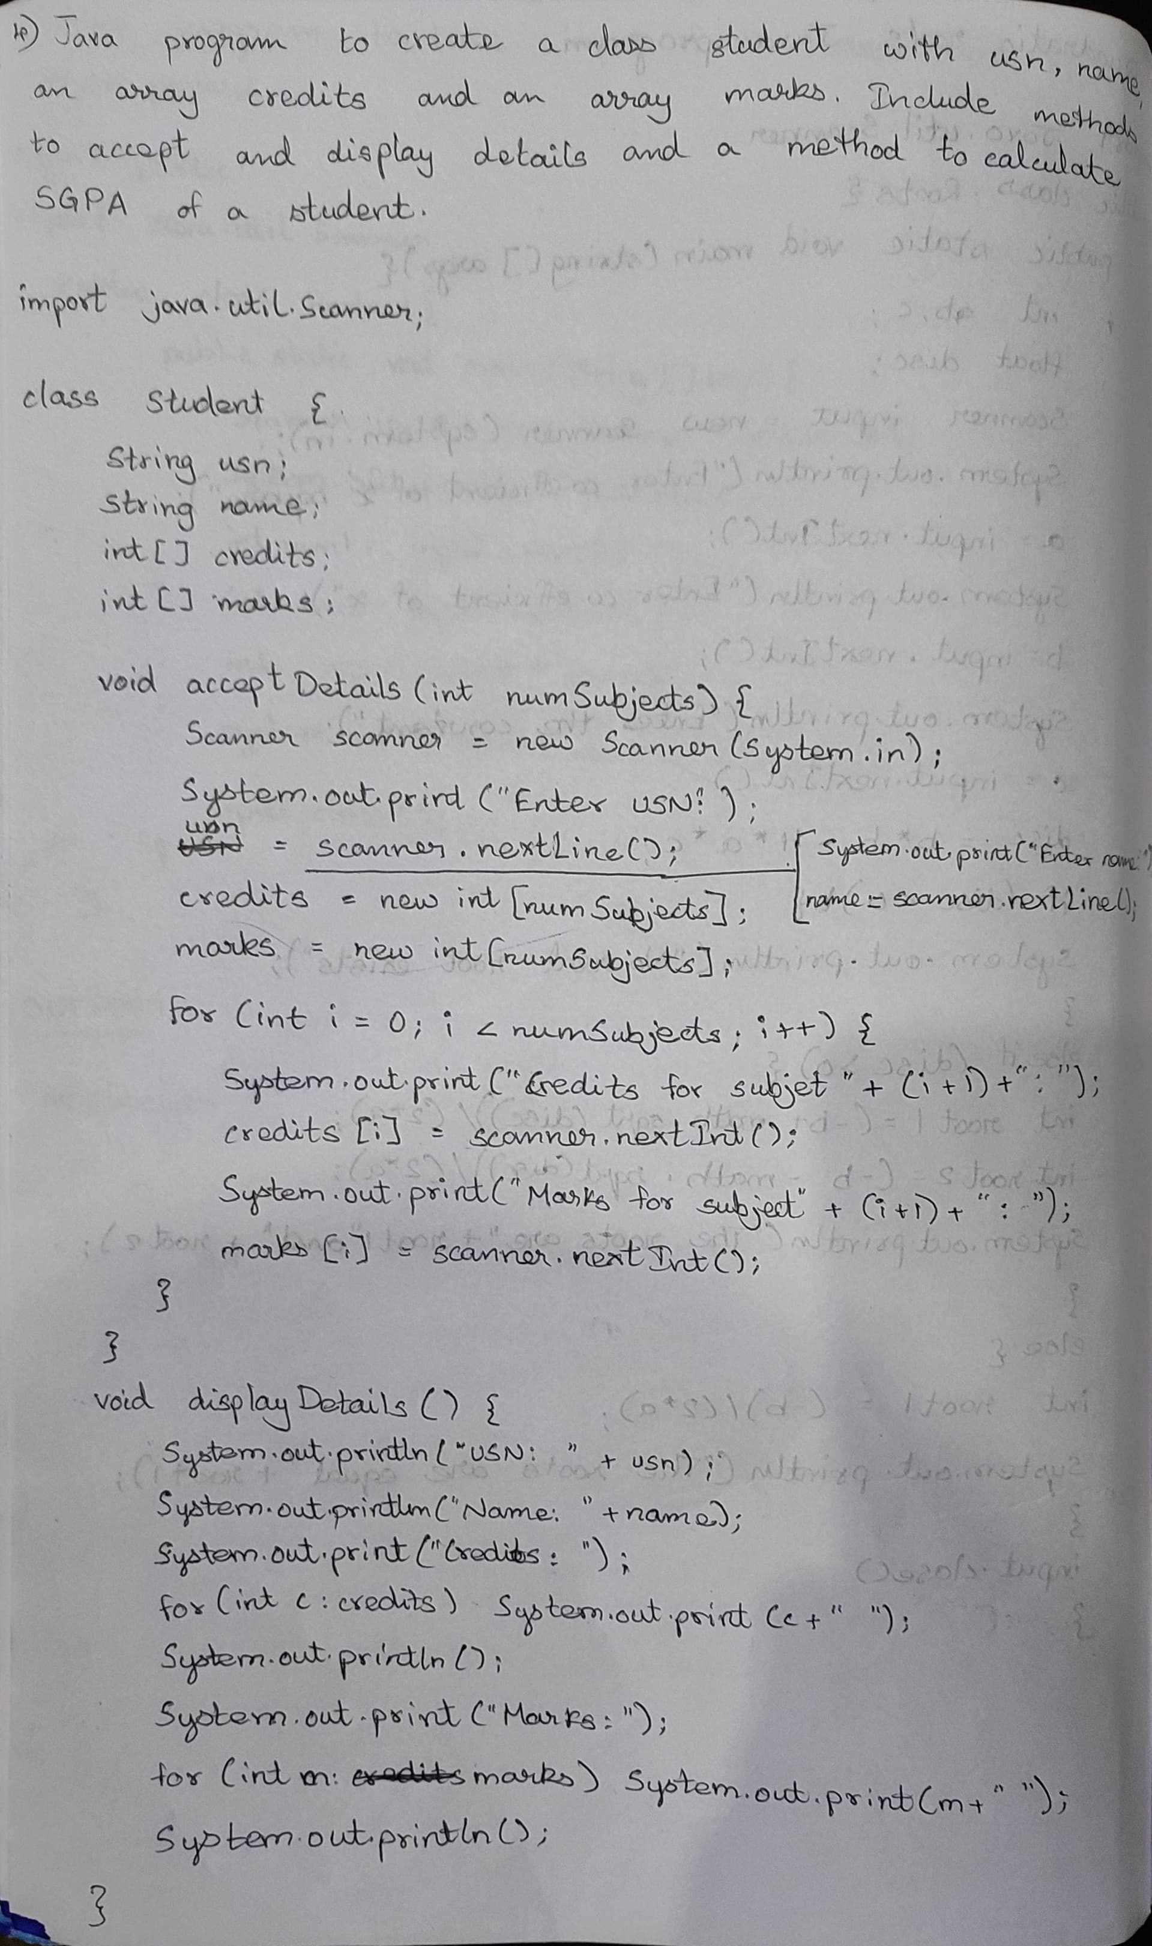

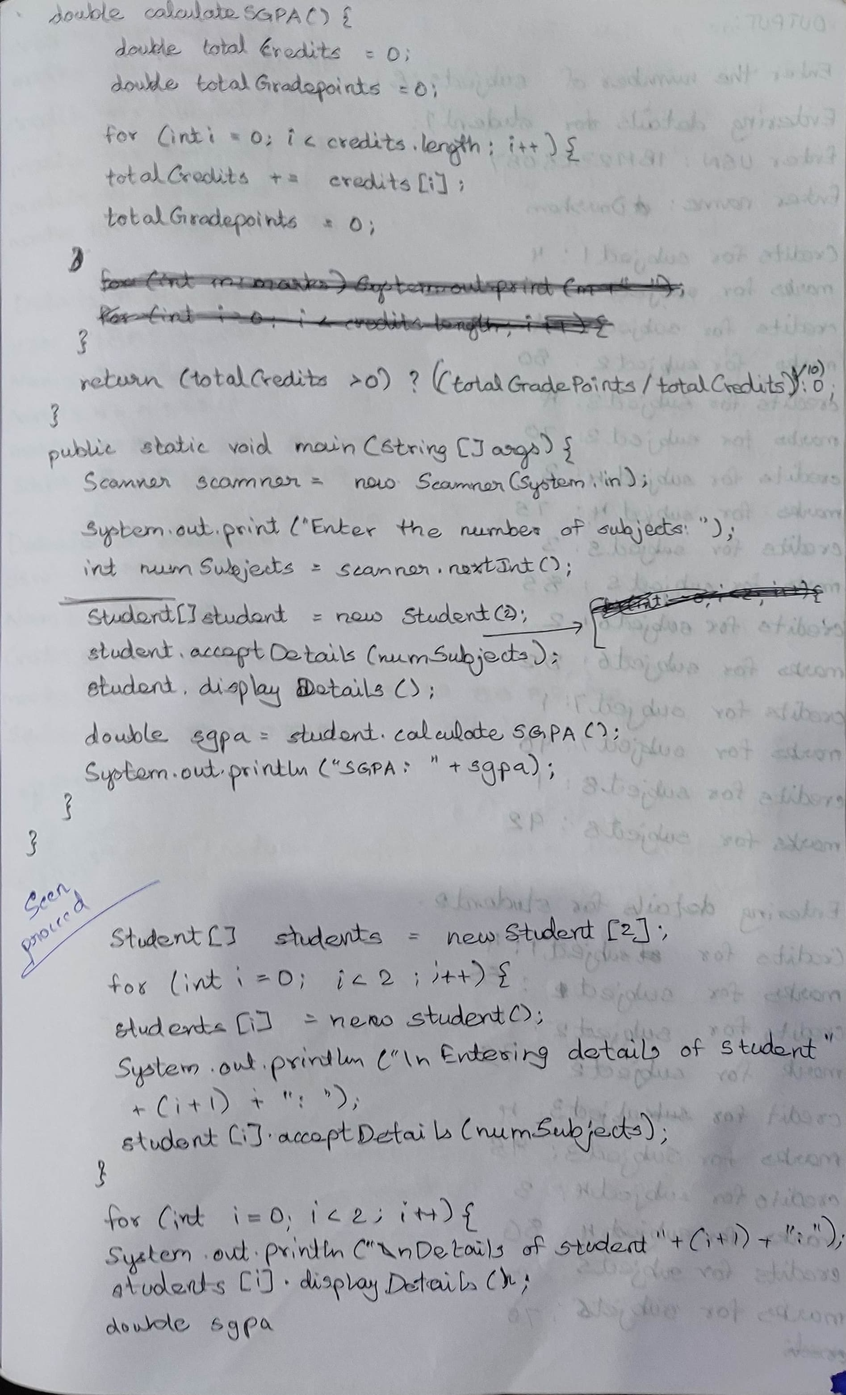

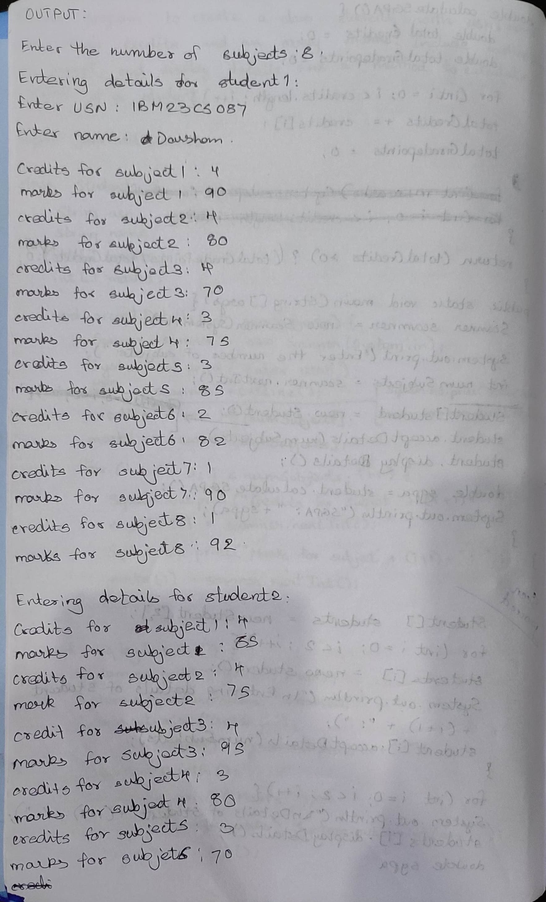

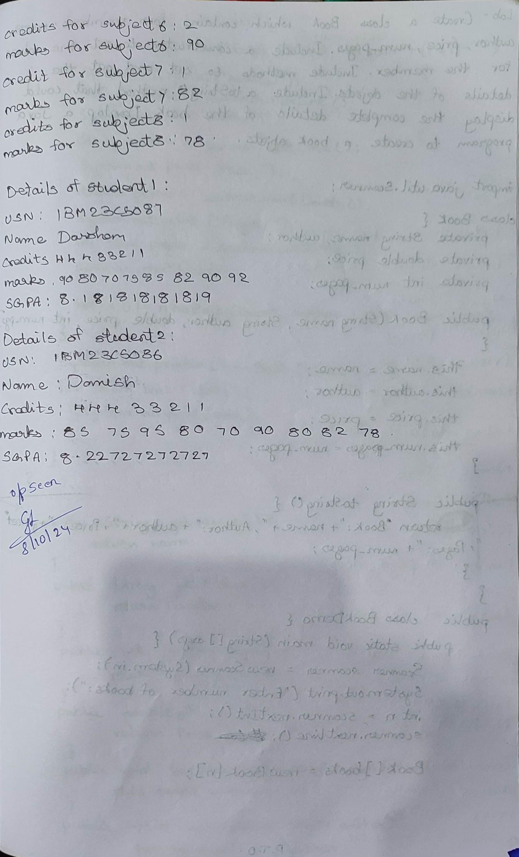

Code:

import java.util.Scanner;

class Student {

String usn;

String name;

int[] credits;

int[] marks;

void acceptDetails(int numSubjects) {

Scanner scanner = new Scanner(System.in);

System.out.print("Enter USN: ");

usn = scanner.nextLine();

System.out.print("Enter Name: ");

name = scanner.nextLine();

credits = new int[numSubjects];

marks = new int[numSubjects];

for (int i = 0; i < numSubjects; i++) {

System.out.print("Credits for subject " + (i + 1) + ": ");

credits[i] = scanner.nextInt();

System.out.print("Marks for subject " + (i + 1) + ": ");

marks[i] = scanner.nextInt();

}

}

void displayDetails() {

System.out.println("USN: " + usn);

System.out.println("Name: " + name);

System.out.print("Credits: ");

for (int c : credits) System.out.print(c + " ");

System.out.println();

System.out.print("Marks: ");

for (int m : marks) System.out.print(m + " ");

System.out.println();

}

double calculateSGPA() {

double totalCredits = 0;

double totalGradepoints = 0;

for (int i = 0; i < credits.length; i++) {

totalCredits += credits[i];

totalGradepoints += 0;

}

return (totalCredits > 0) ? (totalGradepoints / totalCredits) : 0.0;

}

public static void main(String[] args) {

Scanner scanner = new Scanner(System.in);

System.out.println("Darshan YG, 1BM23CS087");

System.out.print("Enter the number of subjects: ");

int numSubjects = scanner.nextInt();

Student[] students = new Student[2];

for (int i = 0; i < 2; i++) {

students[i] = new Student();

System.out.println("\nEntering details of student " + (i + 1) + ":");

students[i].acceptDetails(numSubjects);

}

for (int i = 0; i < 2; i++) {

System.out.println("\nDetails of student " + (i + 1) + ":");

students[i].displayDetails();

}

}

}

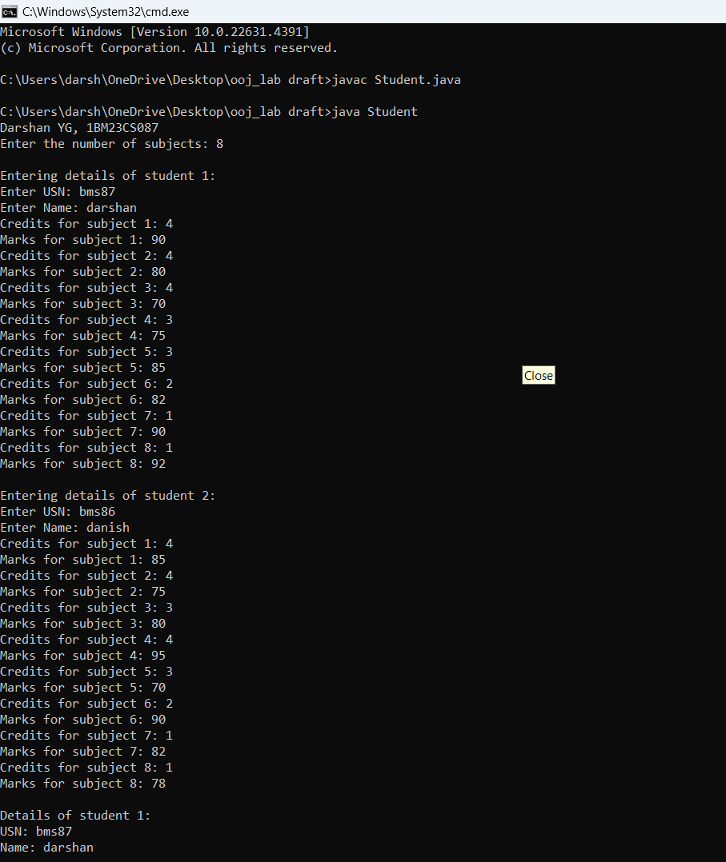

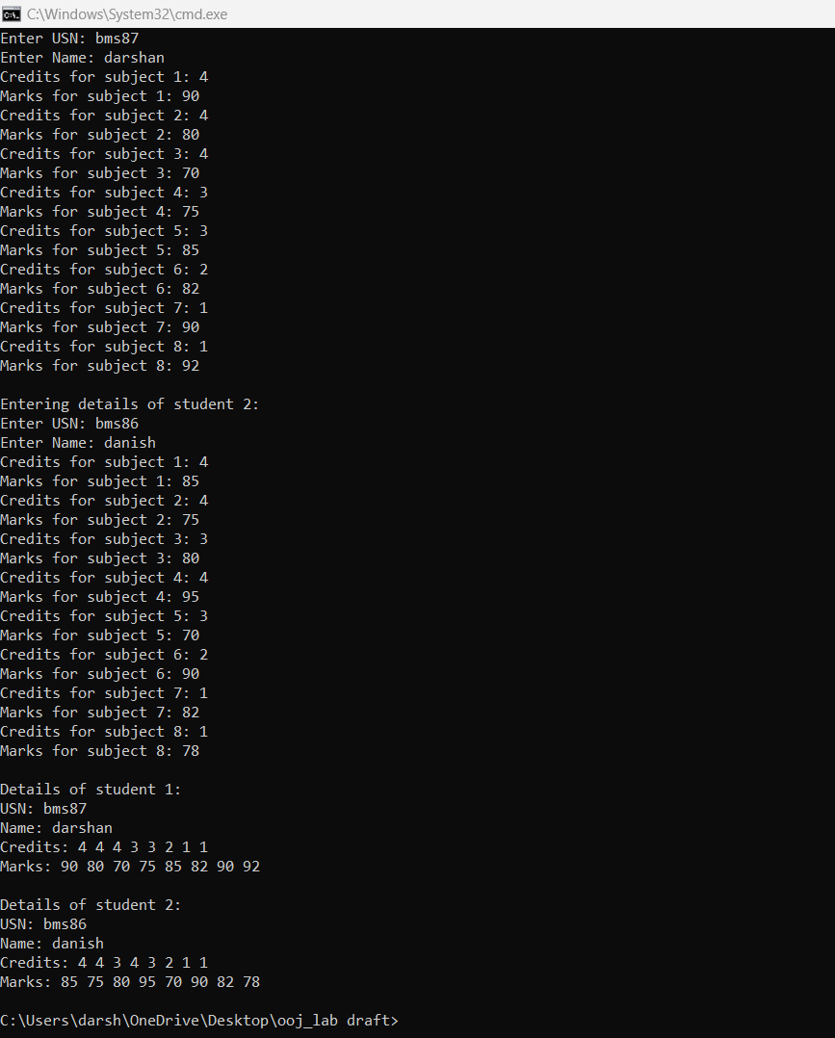

**Program 3**:

Book Details

Algorithm:

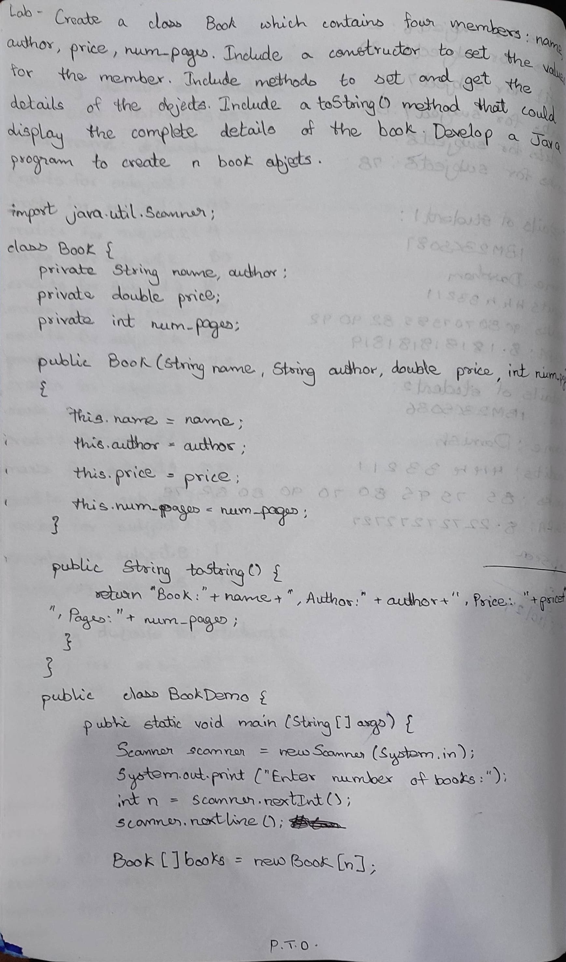

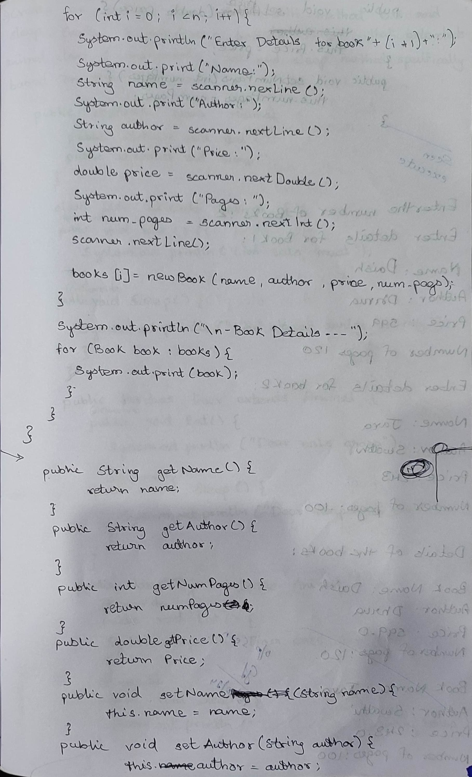

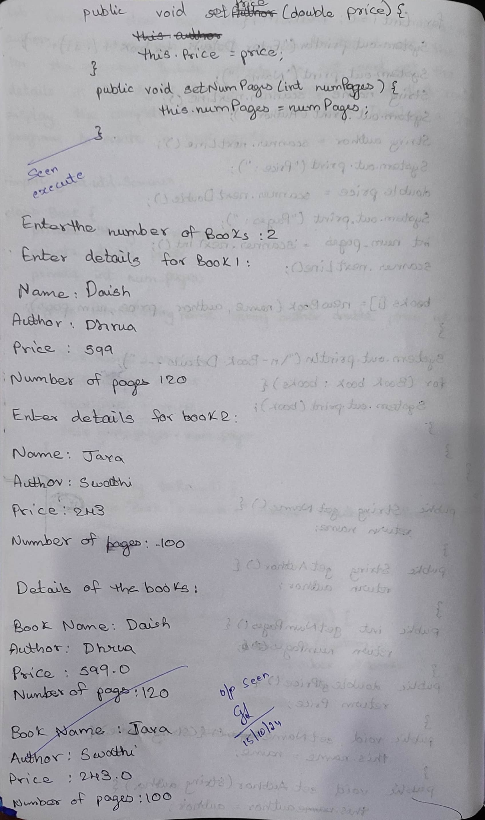

Code:

import java.util.Scanner;

class Book {

private String name, author;

private double price;

private int numPages;

public Book(String name, String author, double price, int numPages) {

this.name = name;

this.author = author;

this.price = price;

this.numPages = numPages;

}

public String getName() {

return name;

}

public String getAuthor() {

return author;

}

public int getNumPages() {

return numPages;

}

public double getPrice() {

return price;

}

public void setName(String name) {

this.name = name;

}

public void setAuthor(String author) {

this.author = author;

}

public void setPrice(double price) {

this.price = price;

}

public void setNumPages(int numPages) {

this.numPages = numPages;

}

public String toString() {

return "Book: " + name + ", Author: " + author + ", Price: " + price + ", Pages: " + numPages;

}

}

public class BookDemo {

public static void main(String[] args) {

Scanner scanner = new Scanner(System.in);

System.out.println("Darshan YG, 1BM23CS087");

System.out.print("Enter number of books: ");

int n = scanner.nextInt();

scanner.nextLine();

Book[] books = new Book[n];

for (int i = 0; i < n; i++) {

System.out.println("Enter Details for book " + (i + 1) + ":");

System.out.print("Name: ");

String name = scanner.nextLine();

System.out.print("Author: ");

String author = scanner.nextLine();

System.out.print("Price: ");

double price = scanner.nextDouble();

System.out.print("Pages: ");

int numPages = scanner.nextInt();

scanner.nextLine();

books[i] = new Book(name, author, price, numPages);

}

System.out.println("\nBook Details---");

for (Book book : books) {

System.out.println(book);

}

scanner.close();

}

}

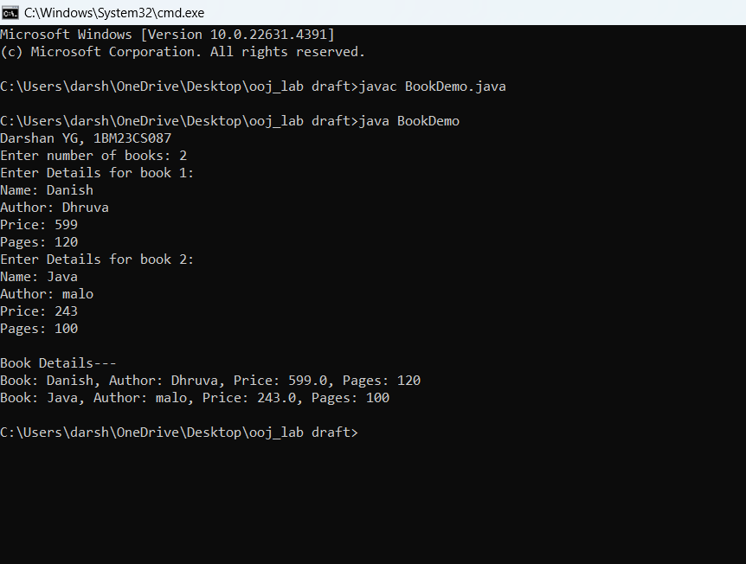

**Program 4:**

Abstract class Animals

Algorithm:

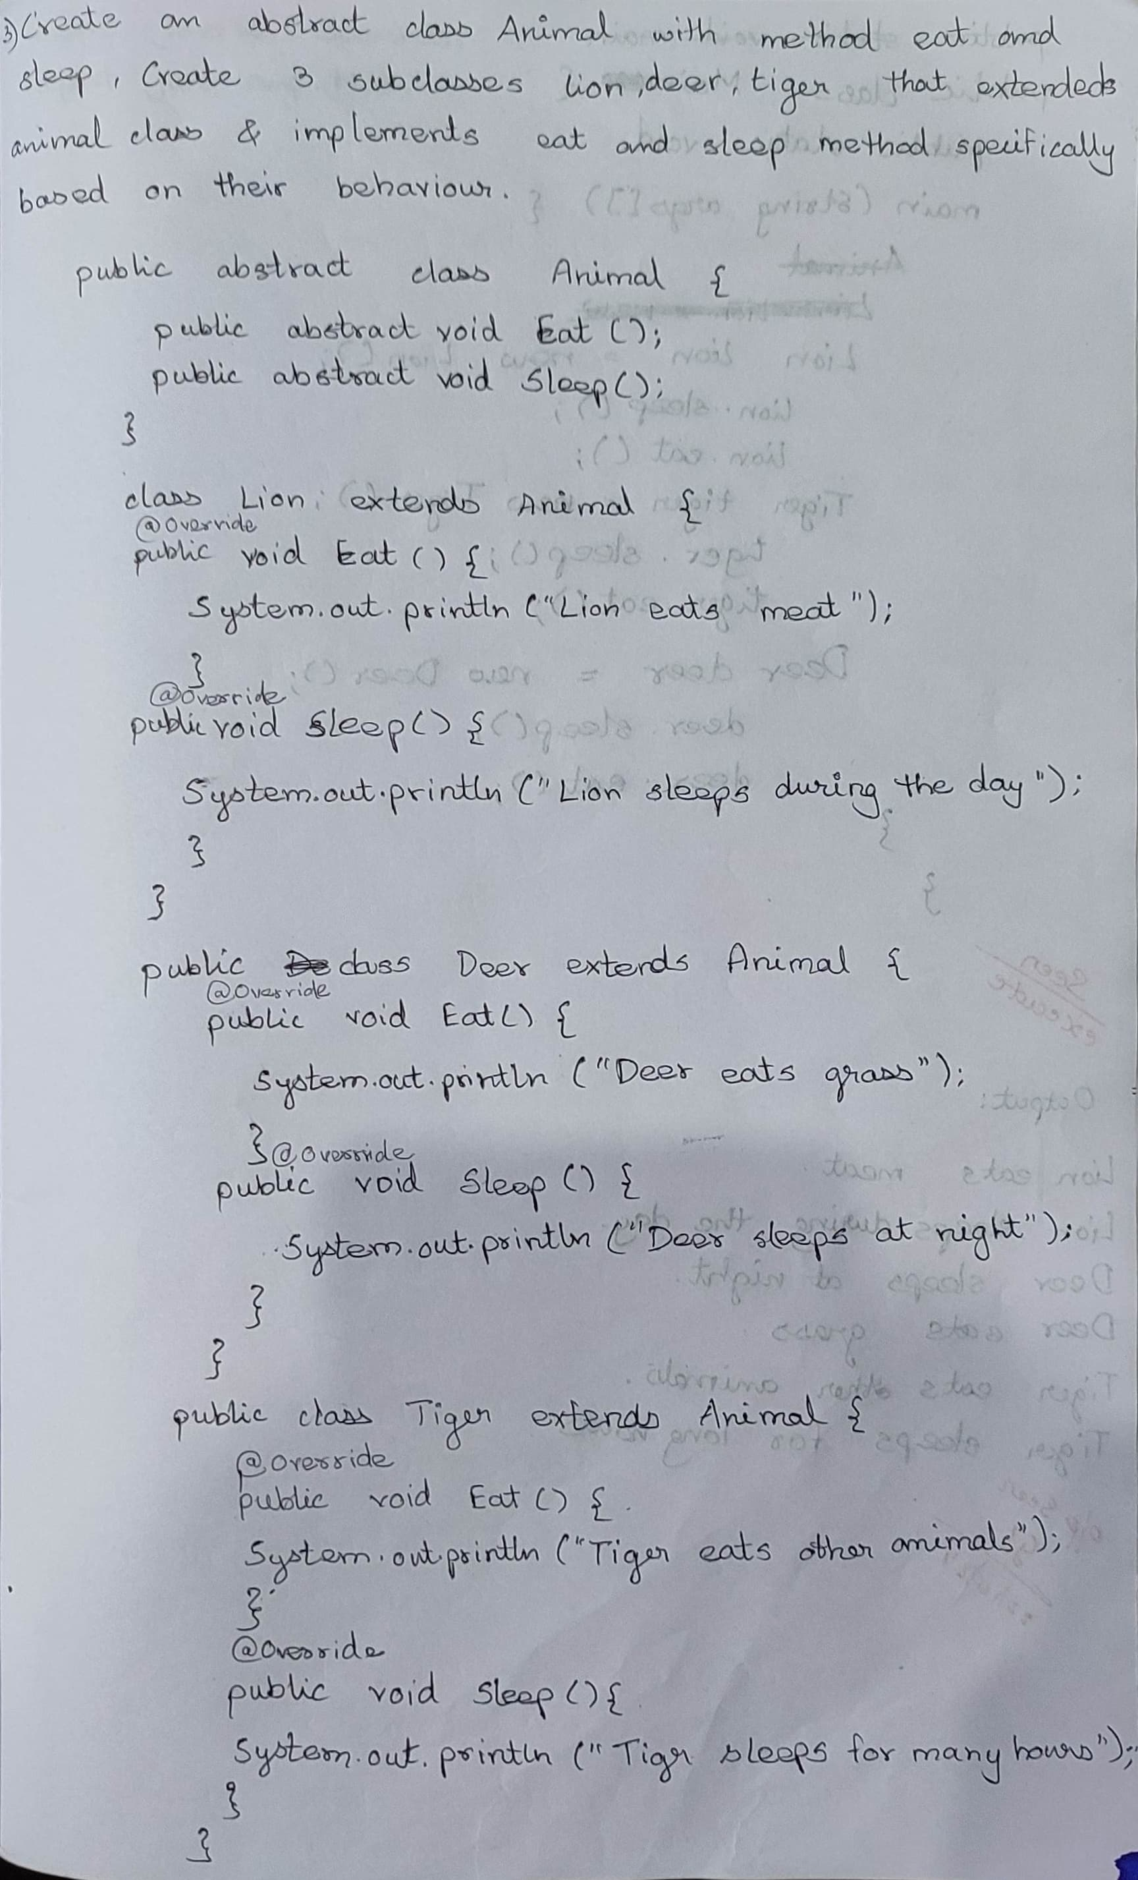

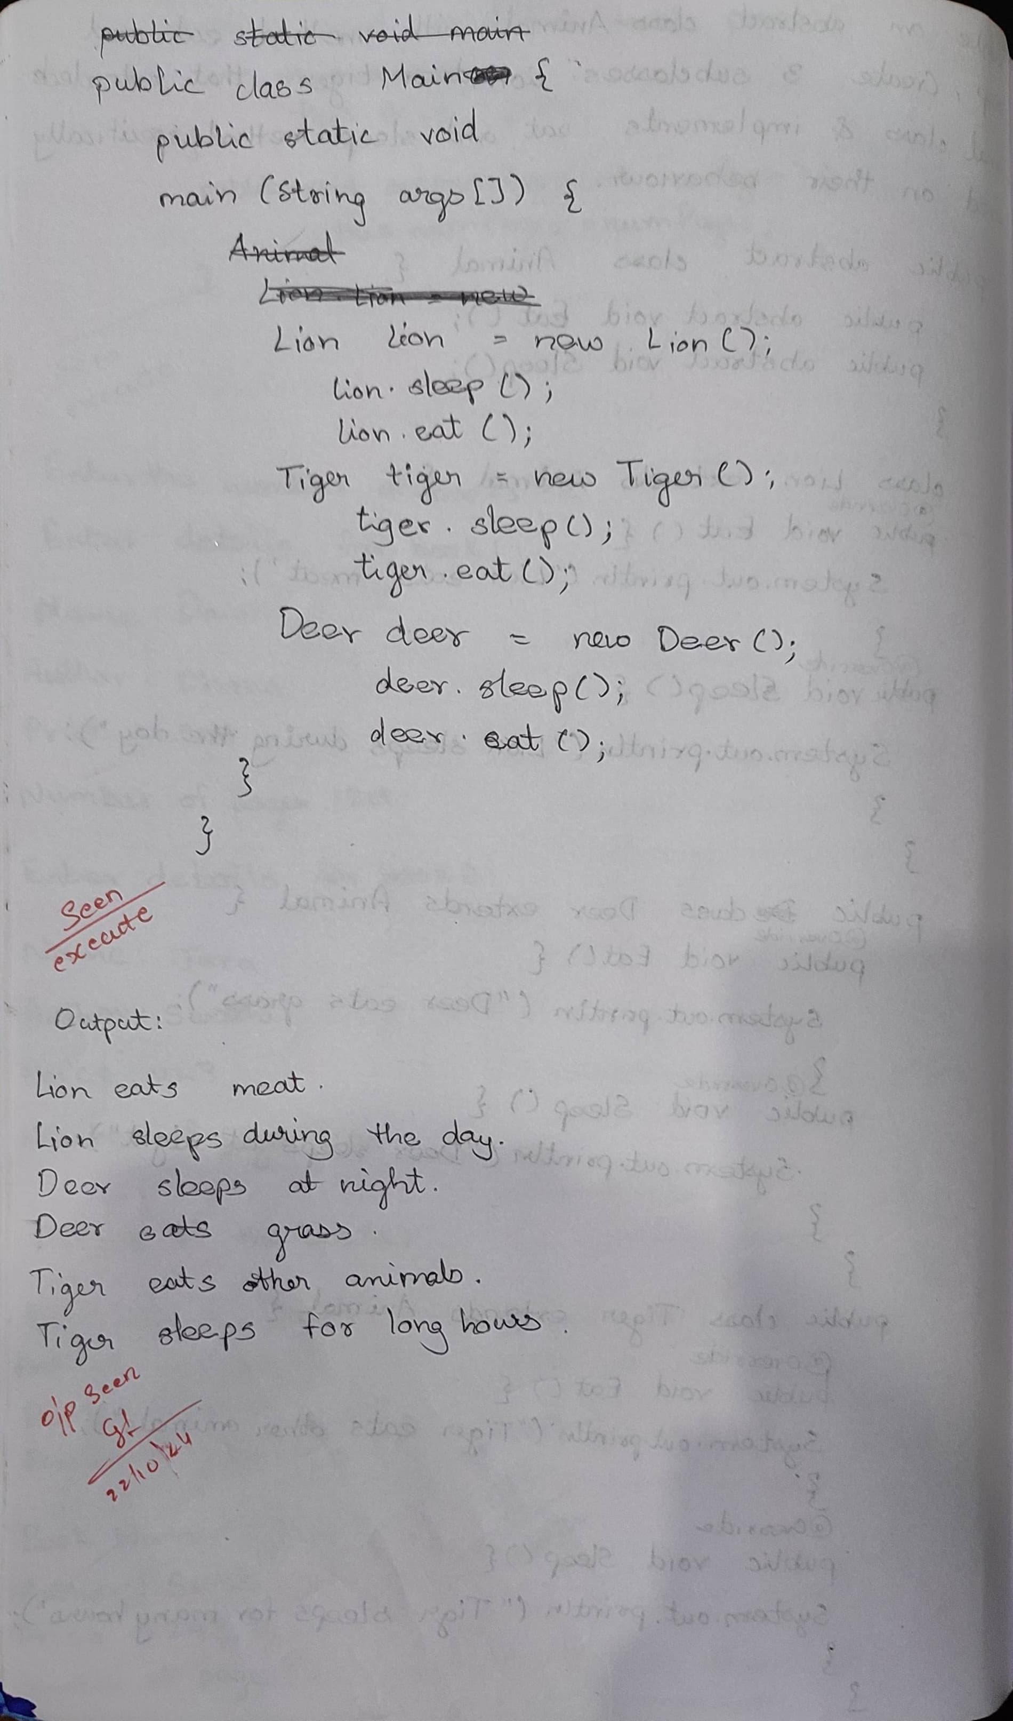

Code:

abstract class Animal {

public abstract void Eat();

public abstract void Sleep();

}

class Lion extends Animal {

@Override

public void Eat() {

System.out.println("Lion eats meat");

}

@Override

public void Sleep() {

System.out.println("Lion sleeps during the day");

}

}

class Deer extends Animal {

@Override

public void Eat() {

System.out.println("Deer eats grass");

}

@Override

public void Sleep() {

System.out.println("Deer sleeps at night");

}

}

class Tiger extends Animal {

@Override

public void Eat() {

System.out.println("Tiger eats other animals");

}

@Override

public void Sleep() {

System.out.println("Tiger sleeps for many hours");

}

}

public class Animals {

public static void main(String args[]) {

System.out.println("Darshan YG, 1BM23CS087");

Lion lion = new Lion();

lion.Sleep();

lion.Eat();

Tiger tiger = new Tiger();

tiger.Sleep();

tiger.Eat();

Deer deer = new Deer();

deer.Sleep();

deer.Eat();

}

}

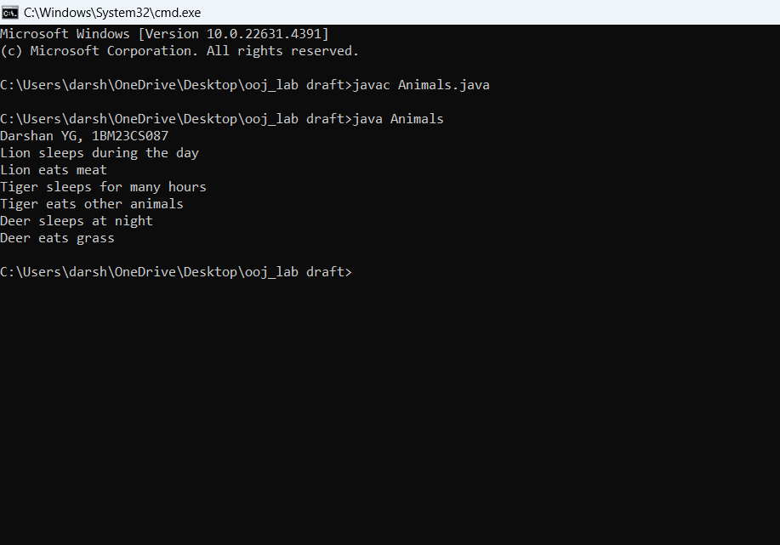

**Program 5:**

Bank Details

Algorithm:

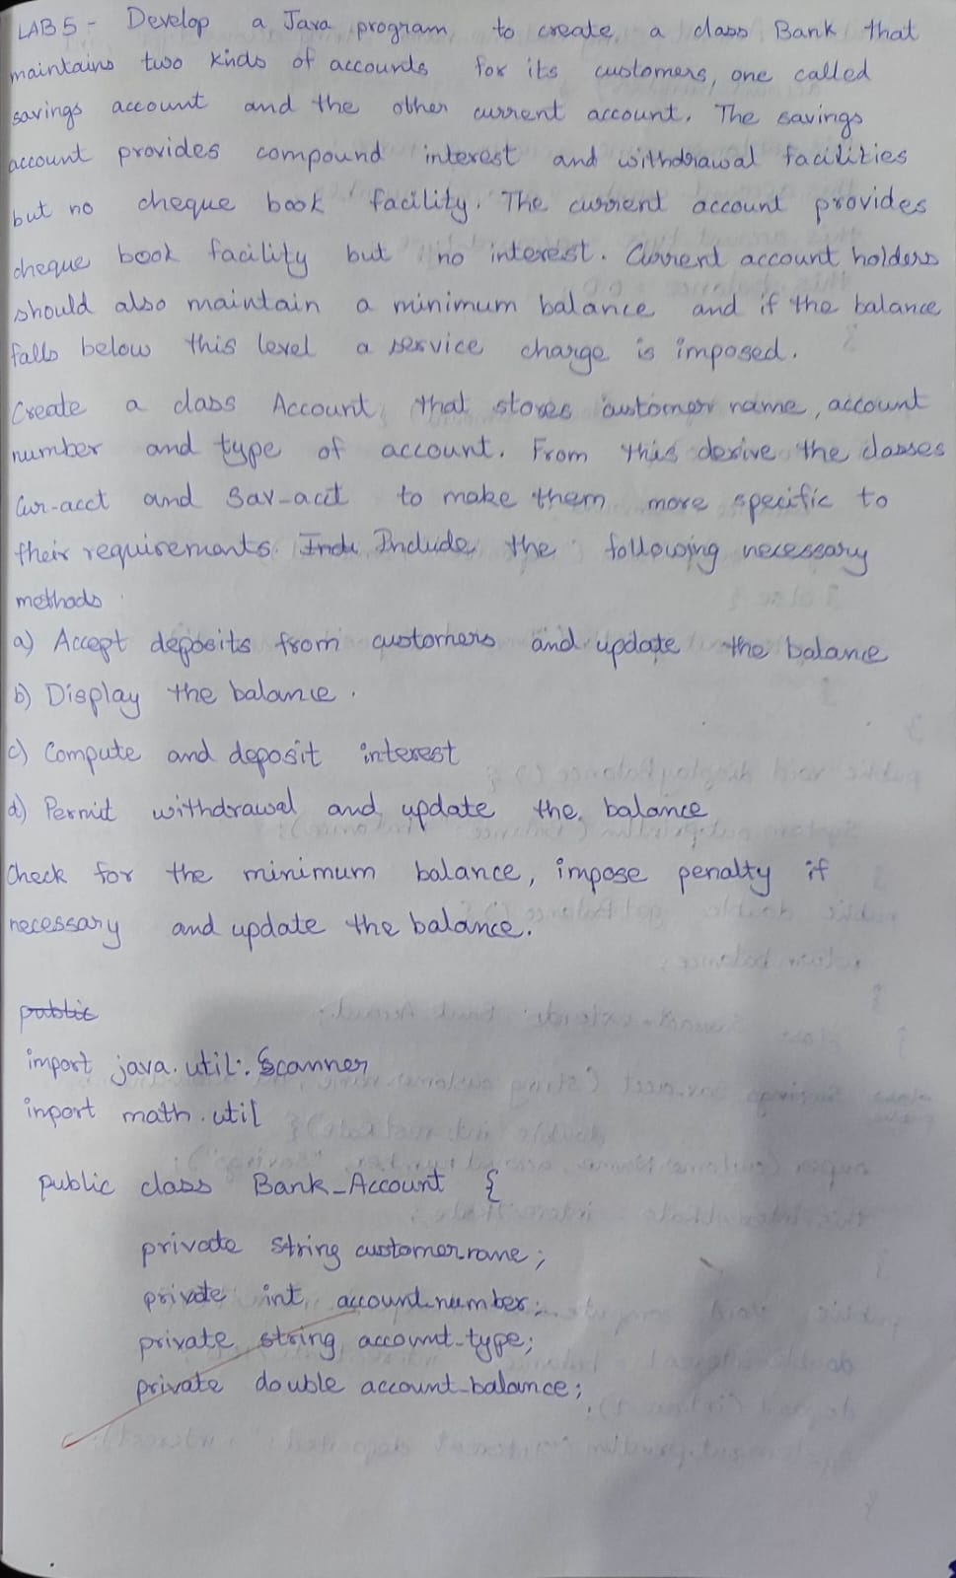

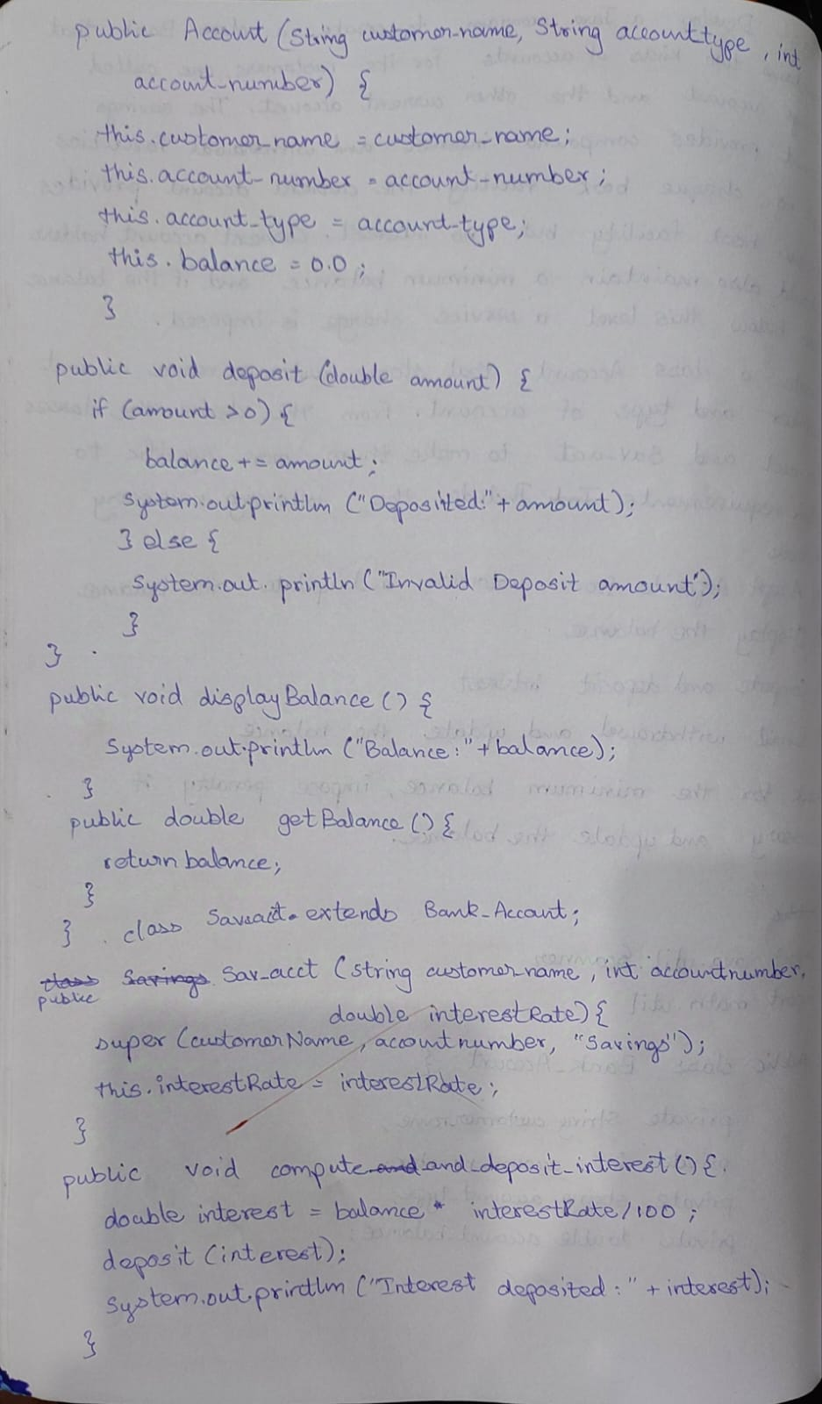

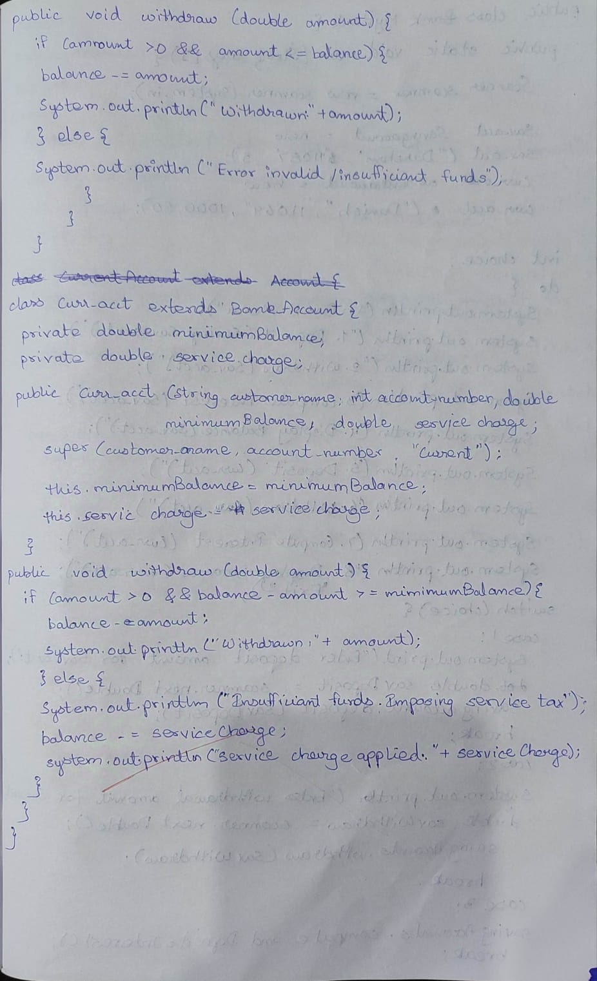

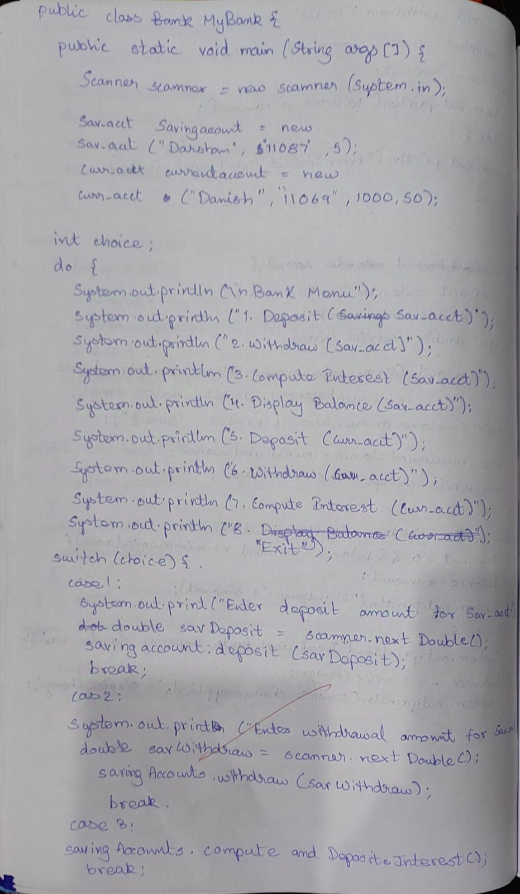

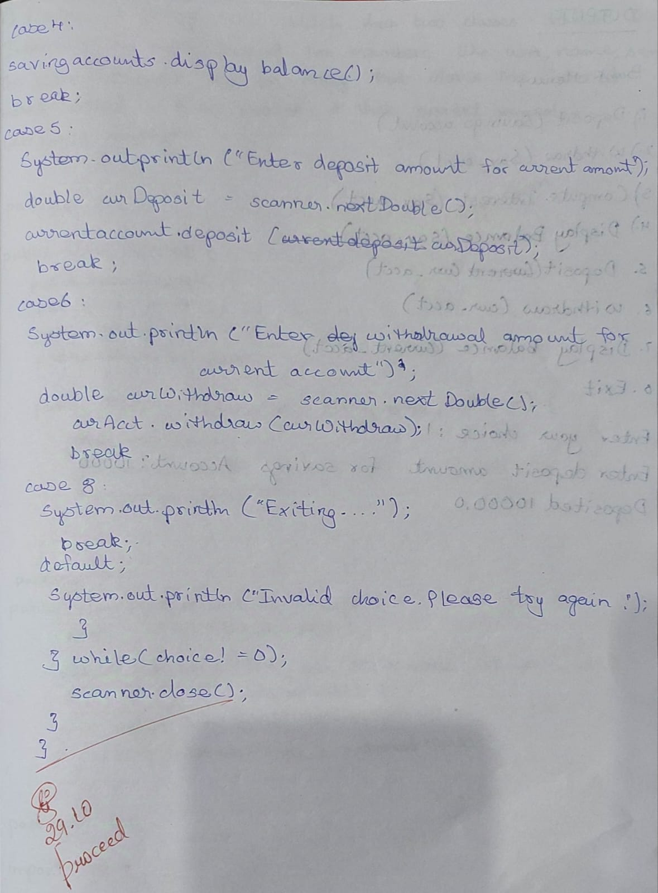

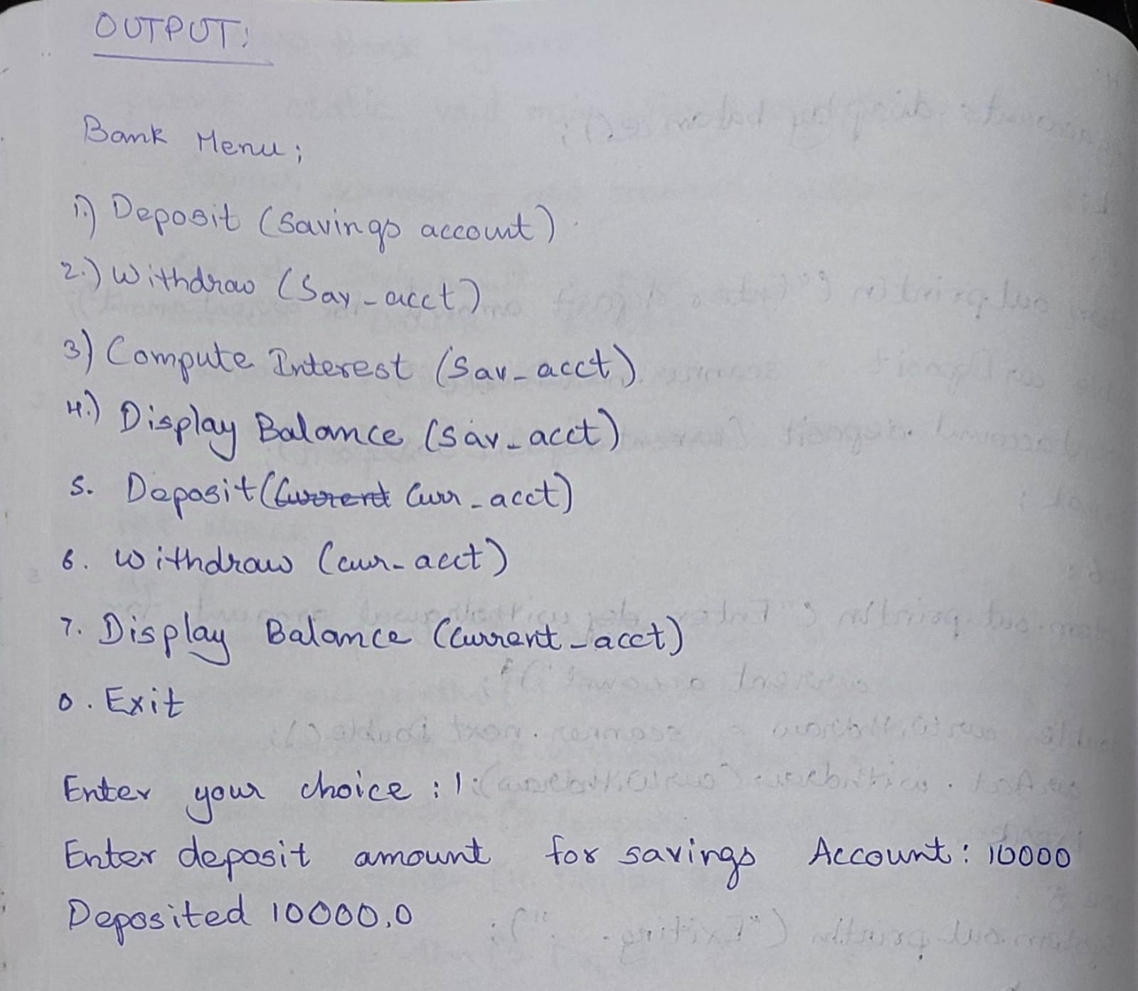

Code:

import java.util.Scanner;

class Bank_Account {

private String customerName;

private String accountNumber;

private String accountType;

protected double balance;

public Bank_Account(String customerName, String accountNumber, String accountType) {

this.customerName = customerName; // Corrected variable names

this.accountNumber = accountNumber; // Corrected variable names

this.accountType = accountType;

this.balance = 0.0;

}

public void deposit(double amount) {

if (amount > 0) {

balance += amount;

System.out.println("Deposited: " + amount);

} else {

System.out.println("Invalid deposit amount.");

}

}

public void displayBalance() {

System.out.println("Balance: " + balance);

}

public double getBalance() {

return balance;

}

}

class Sav_acct extends Bank_Account {

private double interestRate;

public Sav_acct(String customerName, String accountNumber, double interestRate) {

super(customerName, accountNumber, "Savings");

this.interestRate = interestRate;

}

public void computeAndDepositInterest() {

double interest = balance * interestRate / 100;

deposit(interest);

System.out.println("Interest deposited: " + interest);

}

public void withdraw(double amount) {

if (amount > 0 && amount <= balance) {

balance -= amount;

System.out.println("Withdrawn: " + amount);

} else {

System.out.println("Invalid withdrawal amount or insufficient funds.");

}

}

}

class Curr_acct extends Bank_Account {

private double minimumBalance;

private double serviceCharge;

public Curr_acct(String customerName, String accountNumber, double minimumBalance, double serviceCharge) {

super(customerName, accountNumber, "Current"); // Corrected constructor parameter names

this.minimumBalance = minimumBalance; // Corrected variable name

this.serviceCharge = serviceCharge;

}

public void withdraw(double amount) {

if (amount > 0 && balance - amount >= minimumBalance) {

balance -= amount;

System.out.println("Withdrawn: " + amount);

} else {

System.out.println("Insufficient funds. Imposing service charge.");

balance -= serviceCharge;

System.out.println("Service charge applied: " + serviceCharge);

}

}

}

public class MyBank {

public static void main(String[] args) {

Scanner scanner = new Scanner(System.in);

System.out.println("Name-Darshan, USN-1BM23CS087");

Sav_acct savingsAccount = new Sav_acct("Darshan", "11087", 5);

Curr_acct currentAccount = new Curr_acct("Danish", "11069", 100, 50);

int choice;

do {

System.out.println("\nBank Menu:");

System.out.println("1. Deposit (Sav_acct)");

System.out.println("2. Withdraw (Sav_acct)");

System.out.println("3. Compute Interest (Sav_acct)");

System.out.println("4. Display Balance (Sav_acct)");

System.out.println("5. Deposit (Curr_acct)");

System.out.println("6. Withdraw (Curr_acct)");

System.out.println("7. Display Balance (Curr_acct)");

System.out.println("0. Exit");

System.out.print("Enter your choice: ");

choice = scanner.nextInt();

switch (choice) {

case 1:

System.out.print("Enter deposit amount for Savings Account: ");

double savDeposit = scanner.nextDouble();

savingsAccount.deposit(savDeposit); // Corrected method call

break;

case 2:

System.out.print("Enter withdrawal amount for Savings Account: ");

double savWithdraw = scanner.nextDouble();

savingsAccount.withdraw(savWithdraw);

break;

case 3:

savingsAccount.computeAndDepositInterest();

break;

case 4:

savingsAccount.displayBalance();

break;

case 5:

System.out.print("Enter deposit amount for Current Account: ");

double curDeposit = scanner.nextDouble();

currentAccount.deposit(curDeposit);

break;

case 6:

System.out.print("Enter withdrawal amount for Current Account: ");

double curWithdraw = scanner.nextDouble();

currentAccount.withdraw(curWithdraw);

break;

case 7:

currentAccount.displayBalance();

break;

case 0:

System.out.println("Exiting...");

break;

default:

System.out.println("Invalid choice. Please try again.");

}

} while (choice != 0);

scanner.close();

}

}

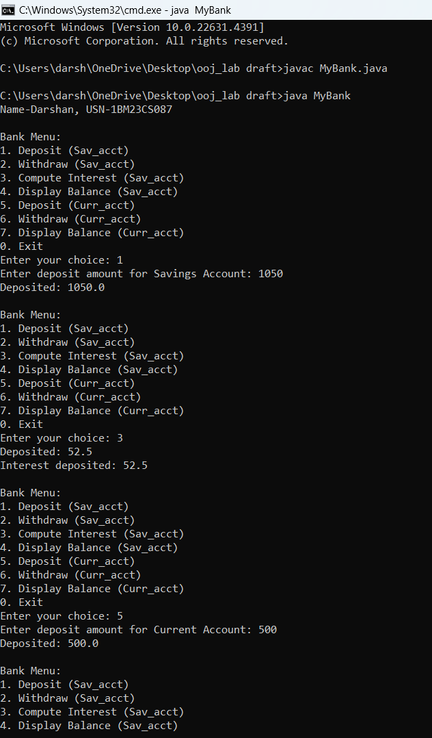

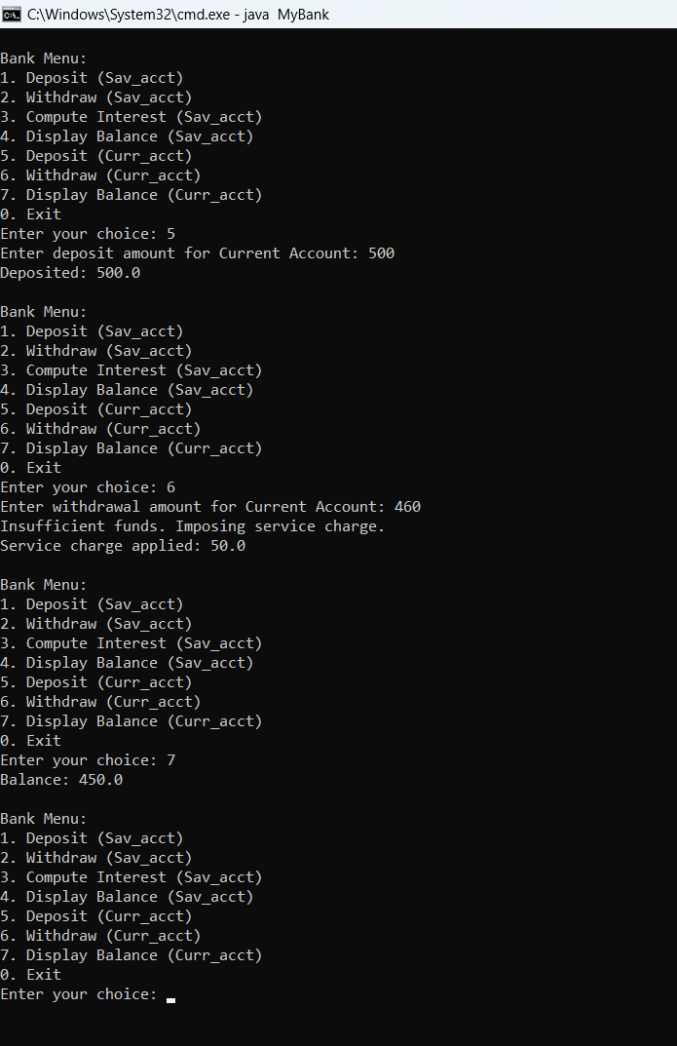

**Program 6**Packages

Algorithm:

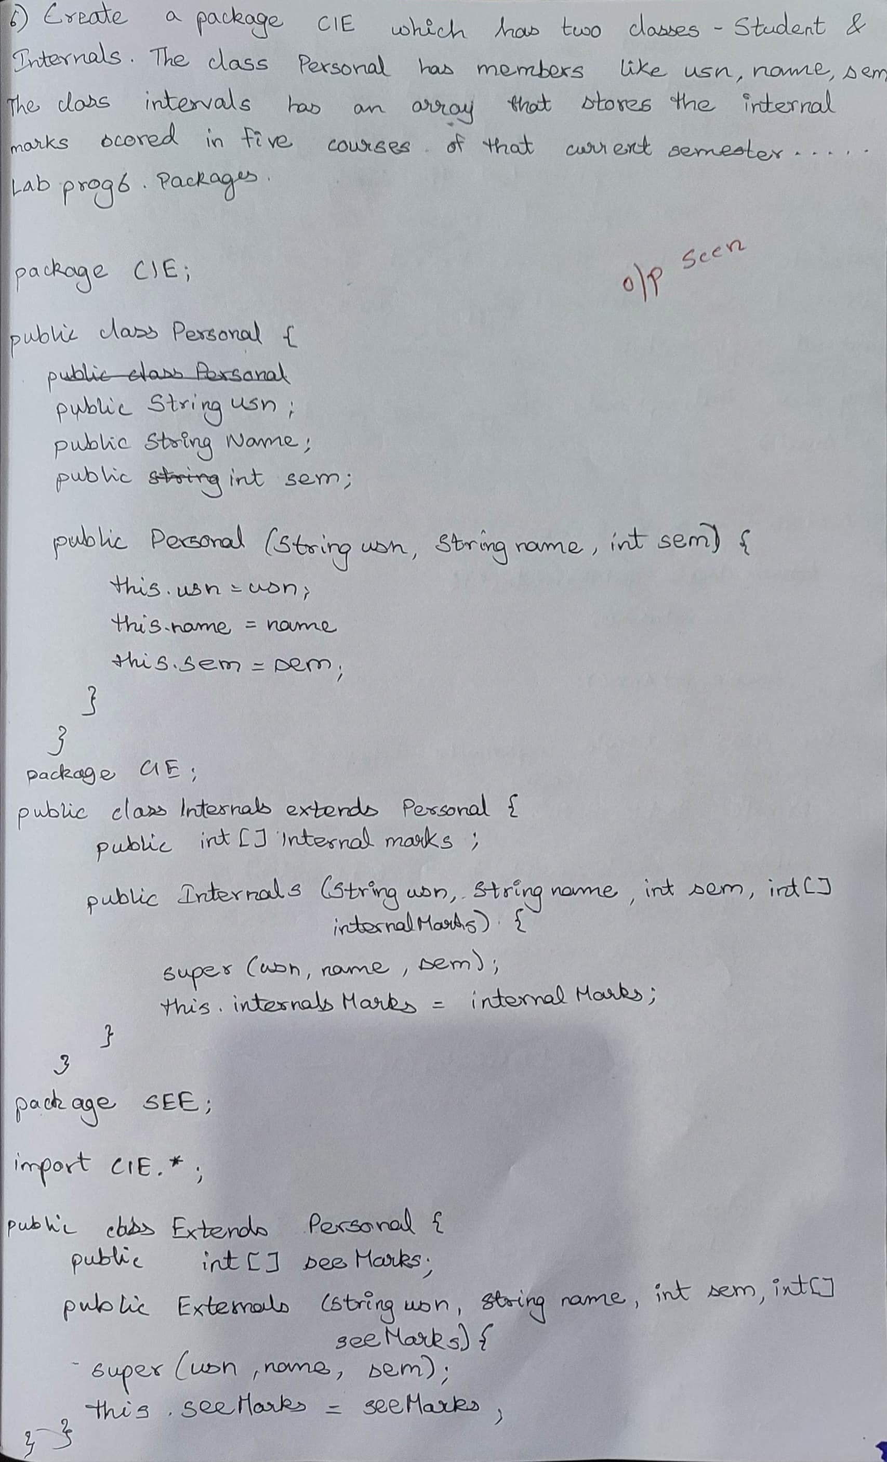

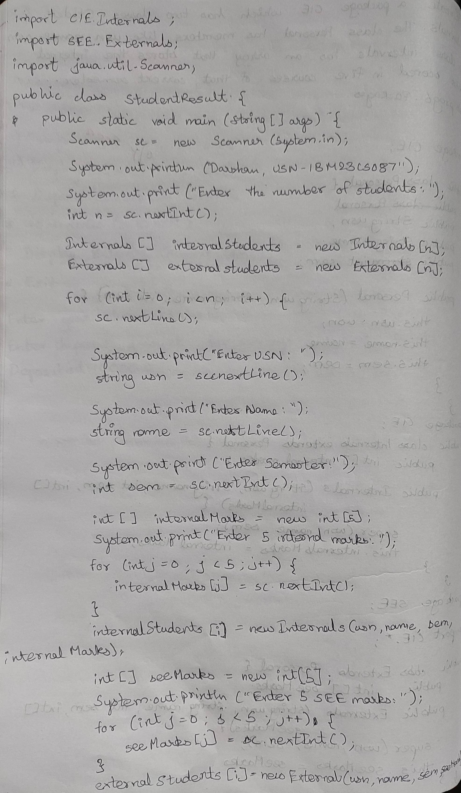

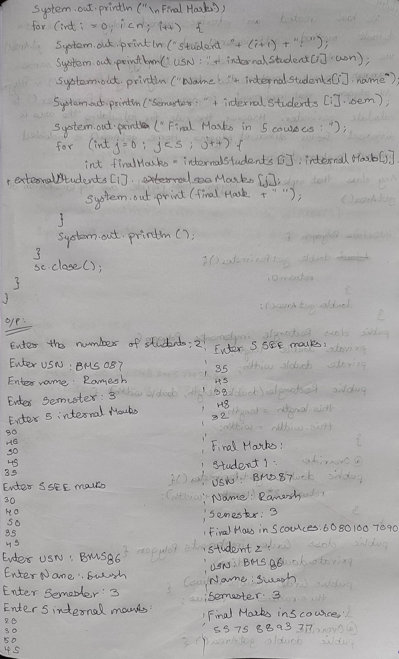

Code:

package CIE;

public class Personal {

public String usn;

public String name;

public int sem;

public Personal(String usn, String name, int sem) {

this.usn = usn;

this.name = name;

this.sem = sem;

}

}

package CIE;

public class Internals extends Personal {

public int[] internalMarks;

public Internals(String usn, String name, int sem, int[] internalMarks) {

super(usn, name, sem);

this.internalMarks = internalMarks;

}

}

package SEE;

import CIE.Personal;

public class External extends Personal {

public int[] seeMarks;

public External(String usn, String name, int sem, int[] seeMarks) {

super(usn, name, sem);

this.seeMarks = seeMarks;

}

}

import CIE.Internals;

import SEE.External;

import java.util.Scanner;

public class StudentResult {

public static void main(String[] args) {

Scanner sc = new Scanner(System.in);

System.out.println("Darshan, USN-1BM23CS087");

System.out.print("Enter the number of students: ");

int n = sc.nextInt();

Internals[] internalStudents = new Internals[n];

External[] externalStudents = new External[n];

for (int i = 0; i < n; i++) {

sc.nextLine();

System.out.print("Enter USN: ");

String usn = sc.nextLine();

System.out.print("Enter Name: ");

String name = sc.nextLine();

System.out.print("Enter Semester: ");

int sem = sc.nextInt();

int[] internalMarks = new int[5];

System.out.println("Enter 5 internal marks:");

for (int j = 0; j < 5; j++) {

internalMarks[j] = sc.nextInt();

}

internalStudents[i] = new Internals(usn, name, sem, internalMarks);

int[] seeMarks = new int[5];

System.out.println("Enter 5 SEE marks:");

for (int j = 0; j < 5; j++) {

seeMarks[j] = sc.nextInt();

}

externalStudents[i] = new External(usn, name, sem, seeMarks);

}

System.out.println("\nFinal Marks:");

for (int i = 0; i < n; i++) {

System.out.println("Student " + (i + 1) + ":");

System.out.println("USN: " + internalStudents[i].usn);

System.out.println("Name: " + internalStudents[i].name);

System.out.println("Semester: " + internalStudents[i].sem);

System.out.print("Final Marks in 5 Courses: ");

for (int j = 0; j < 5; j++) {

int finalMark = internalStudents[i].internalMarks[j] + externalStudents[i].seeMarks[j];

System.out.print(finalMark + " ");

}

System.out.println();

}

sc.close();

}

}

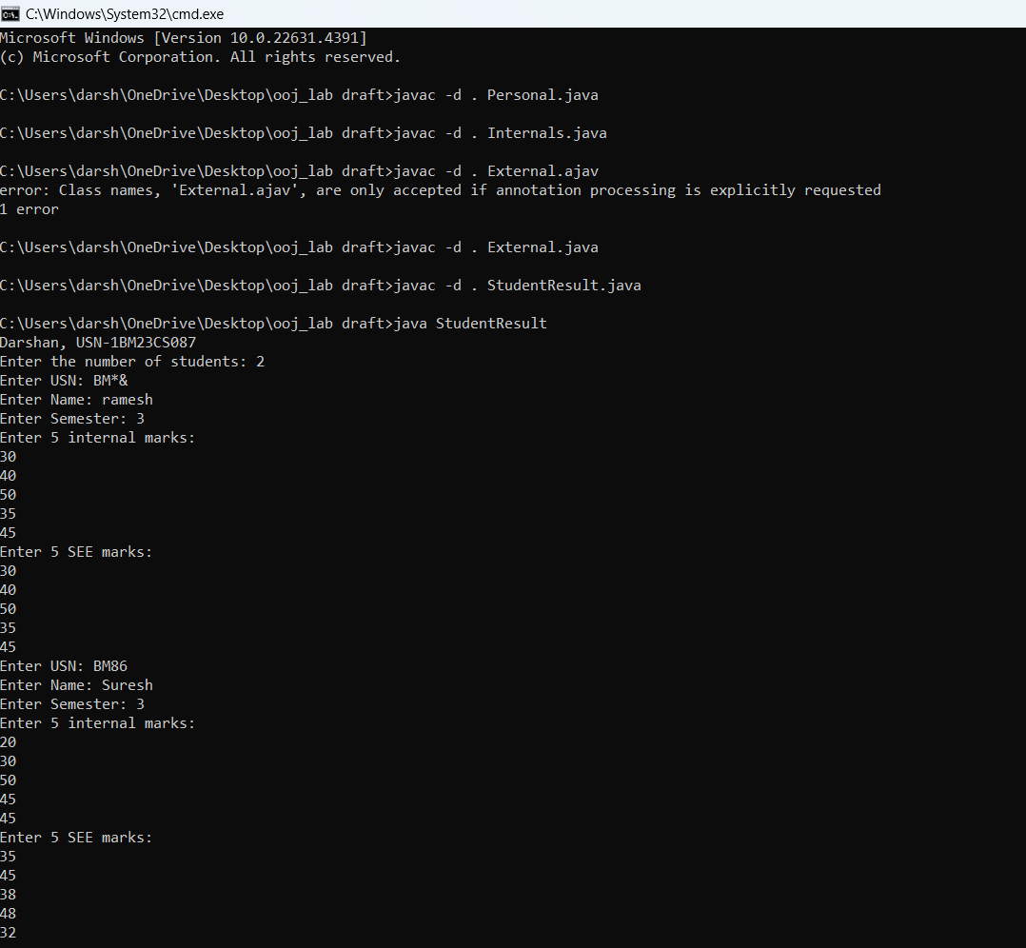

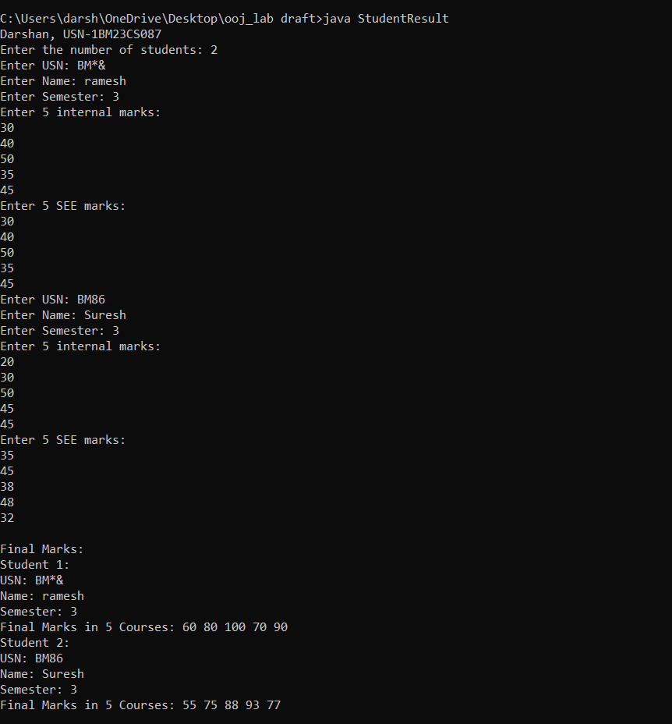

**Program 7**

Interface

Algorithm

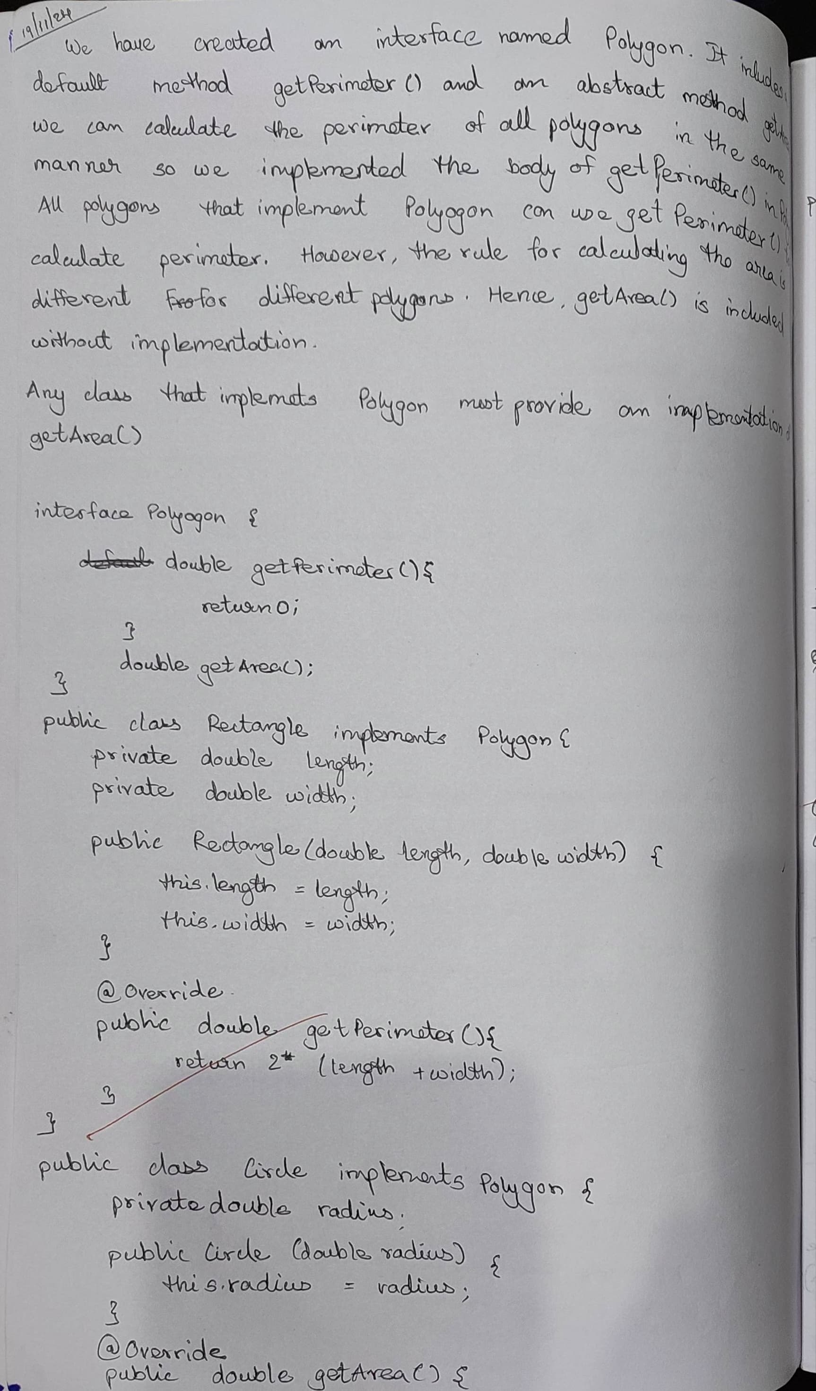

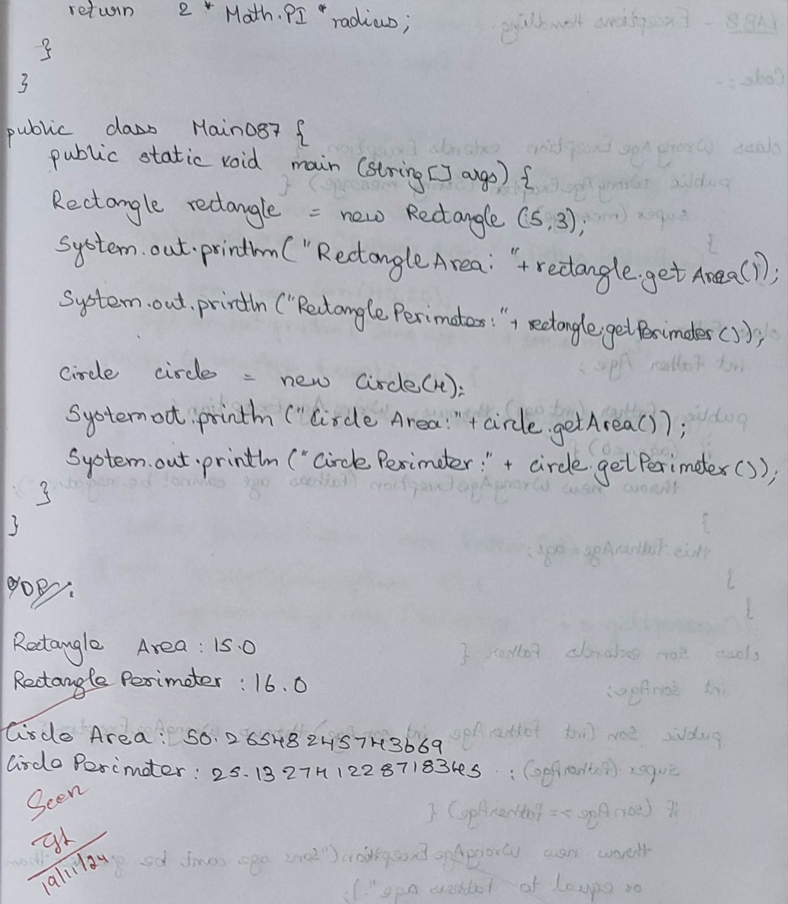

Code:

interface Polygon {

double getArea();

double getPerimeter();

}

class Rectangle implements Polygon {

private double length, width;

public Rectangle(double length, double width) {

this.length = length;

this.width = width;

}

@Override

public double getArea() {

return length * width;

}

@Override

public double getPerimeter() {

return 2 * (length + width);

}

}

class Circle implements Polygon {

private double radius;

public Circle(double radius) {

this.radius = radius;

}

@Override

public double getArea() {

return Math.PI * radius * radius;

}

@Override

public double getPerimeter() {

return 2 * Math.PI * radius;

}

}

public class ShapesSize {

public static void main(String[] args) {

System.out.println("Darshan-1BM23CS087");

Rectangle rectangle = new Rectangle(5, 3);

System.out.println("Rectangle Area: " + rectangle.getArea());

System.out.println("Rectangle Perimeter: " + rectangle.getPerimeter());

Circle circle = new Circle(4);

System.out.println("Circle Area: " + circle.getArea());

System.out.println("Circle Perimeter: " + circle.getPerimeter());

}

}

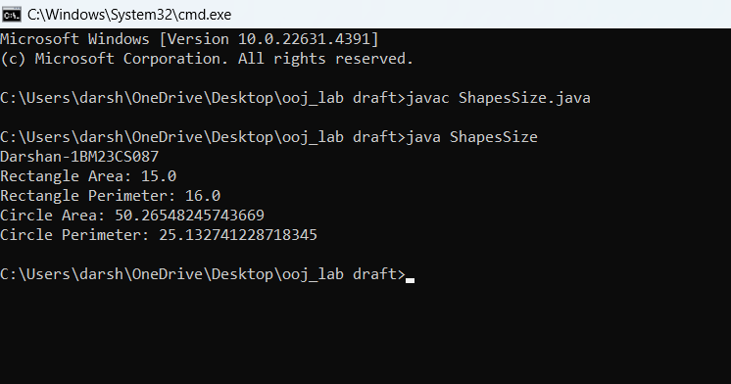

**Program 8**

Exception Handling

Algorithm:

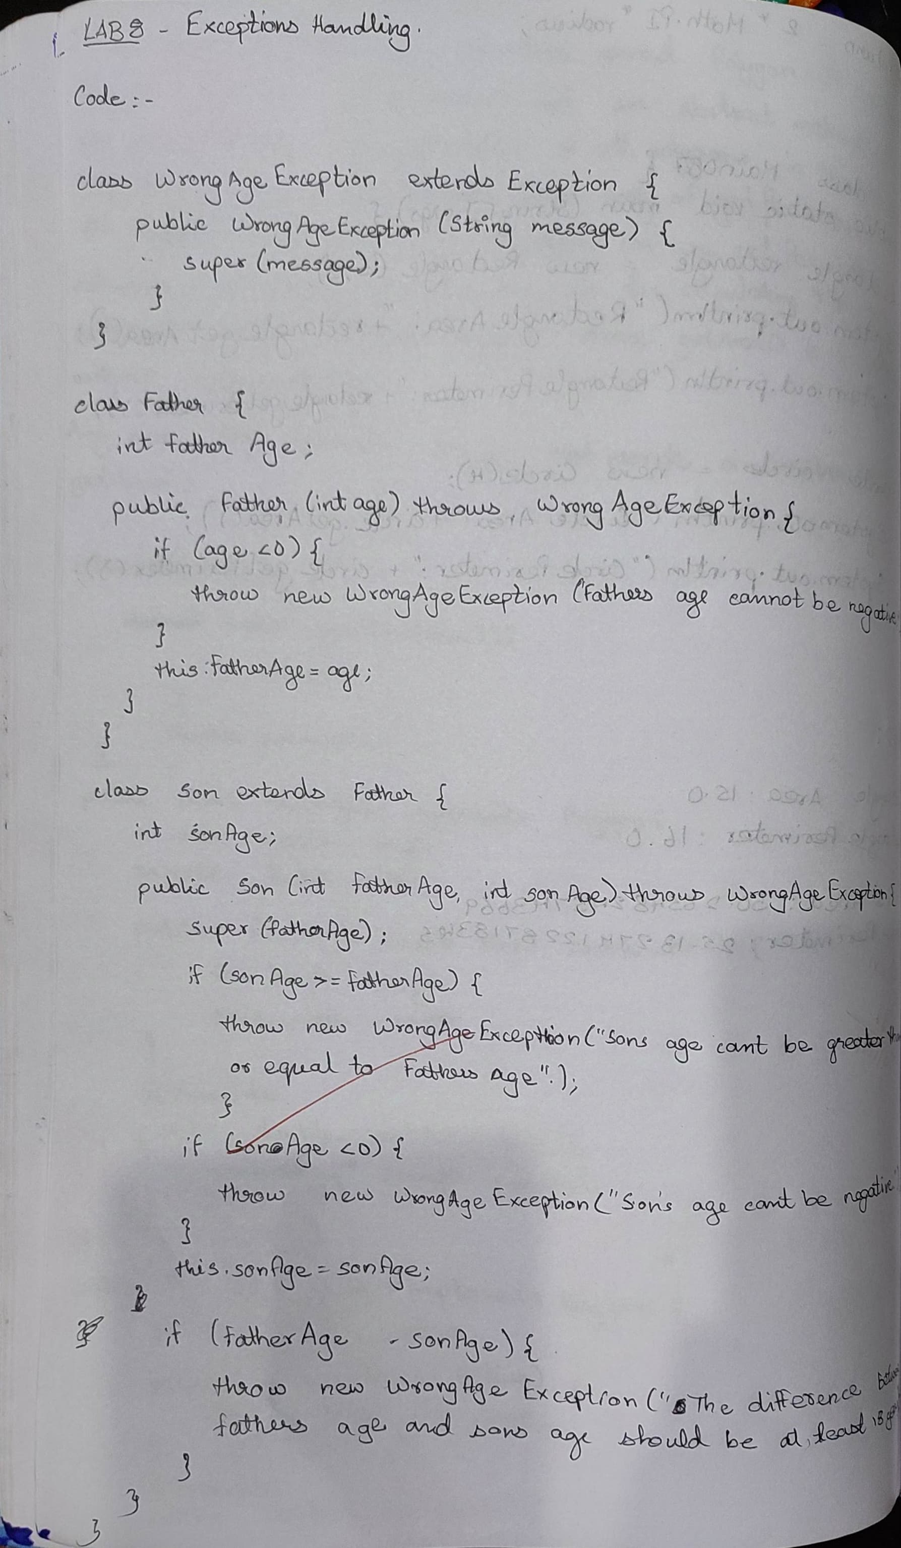

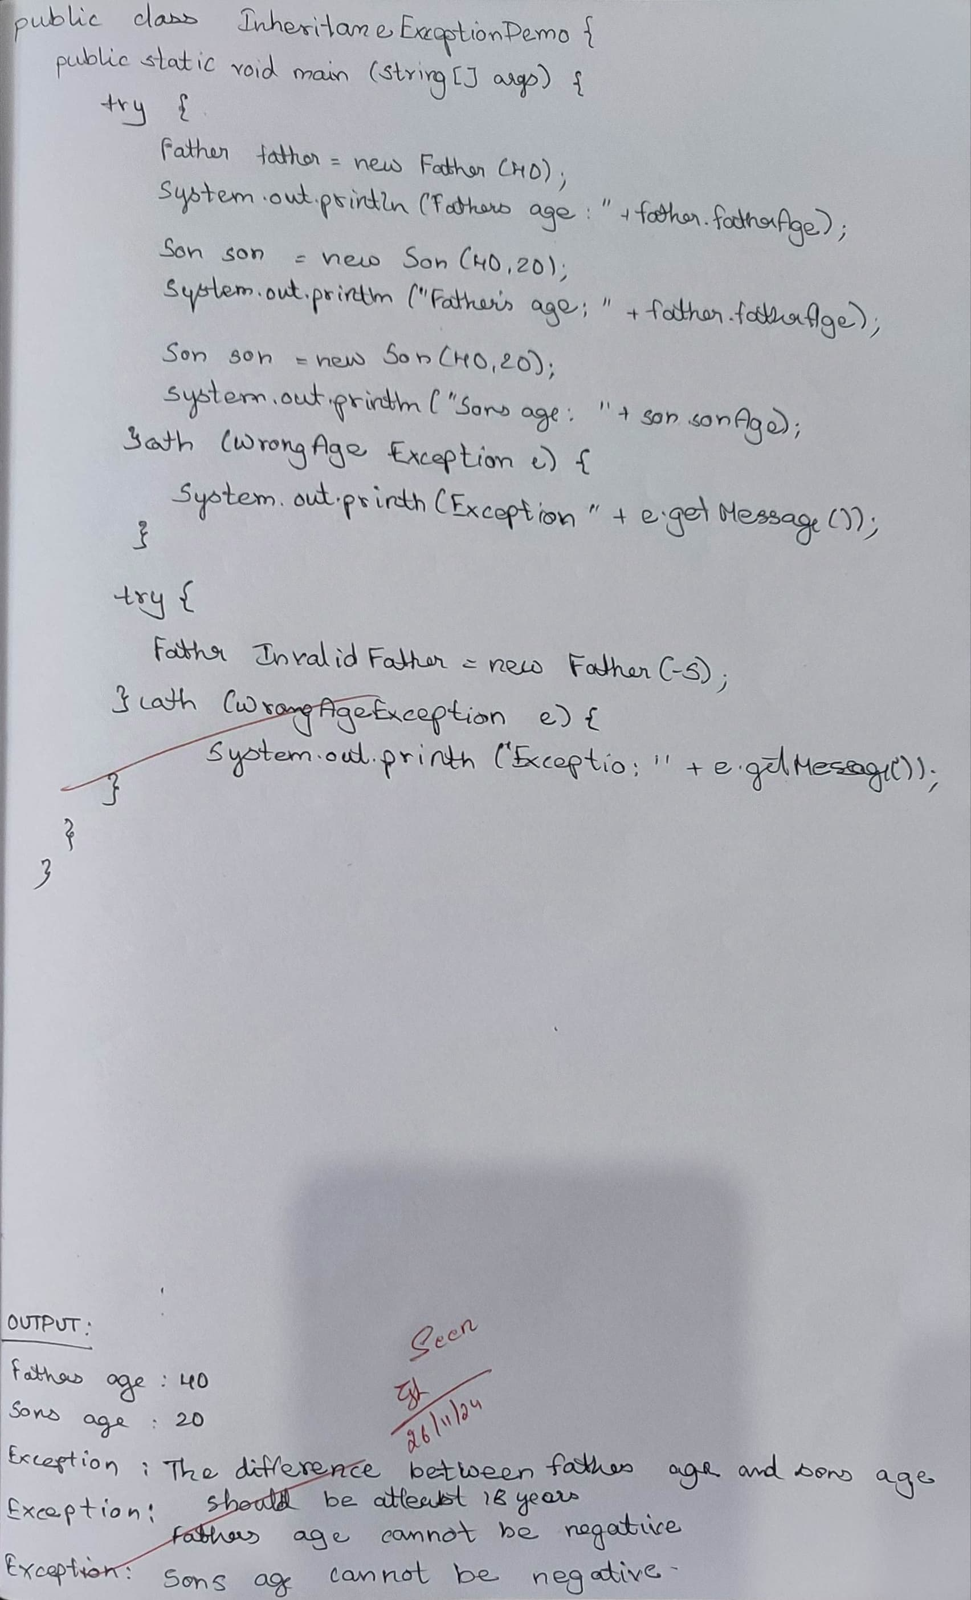

Code:

class WrongAgeException extends Exception {

public WrongAgeException(String message) {

super(message);

}

}

class Father {

int fatherAge;

public Father(int age) throws WrongAgeException {

if (age < 0) {

throw new WrongAgeException("Father's age cannot be negative.");

}

this.fatherAge = age;

}

}

class Son extends Father {

int sonAge;

public Son(int fatherAge, int sonAge) throws WrongAgeException {

super(fatherAge);

if (sonAge >= fatherAge) {

throw new WrongAgeException("Son's age cannot be greater than or equal to Father's age.");

}

if (sonAge < 0) {

throw new WrongAgeException("Son's age cannot be negative.");

}

if (fatherAge - sonAge < 18) {

throw new WrongAgeException("The age difference between Father and Son must be at least 18 years.");

}

this.sonAge = sonAge;

}

}

public class InheritanceExceptionDemo {

public static void main(String[] args) {

System.out.println("Darshan, 1BM23CS087");

try {

Father father = new Father(40);

System.out.println("Father's age: " + father.fatherAge);

Son son = new Son(40, 20);

System.out.println("Son's age: " + son.sonAge);

} catch (WrongAgeException e) {

System.out.println("Exception: " + e.getMessage());

}

try {

Son invalidSon = new Son(30, 30);

} catch (WrongAgeException e) {

System.out.println("Exception: " + e.getMessage());

}

try {

Father invalidFather = new Father(-5);

} catch (WrongAgeException e) {

System.out.println("Exception: " + e.getMessage());

}

try {

Son invalidAgeDifference = new Son(35, 20);

} catch (WrongAgeException e) {

System.out.println("Exception: " + e.getMessage());

}

}

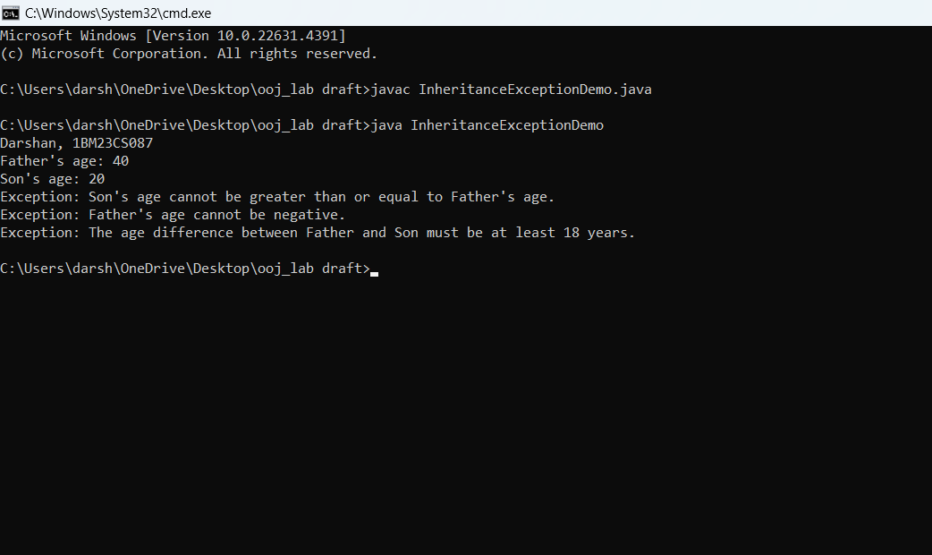

**Program 9**

Threads

Algorithm:

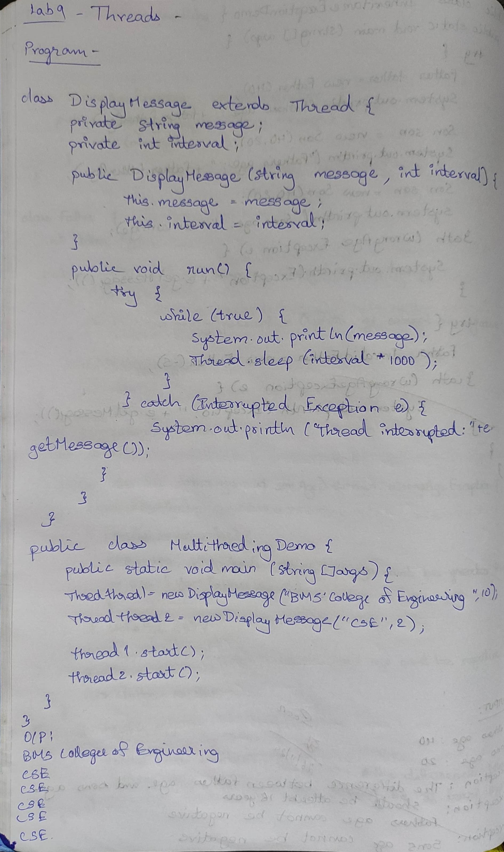

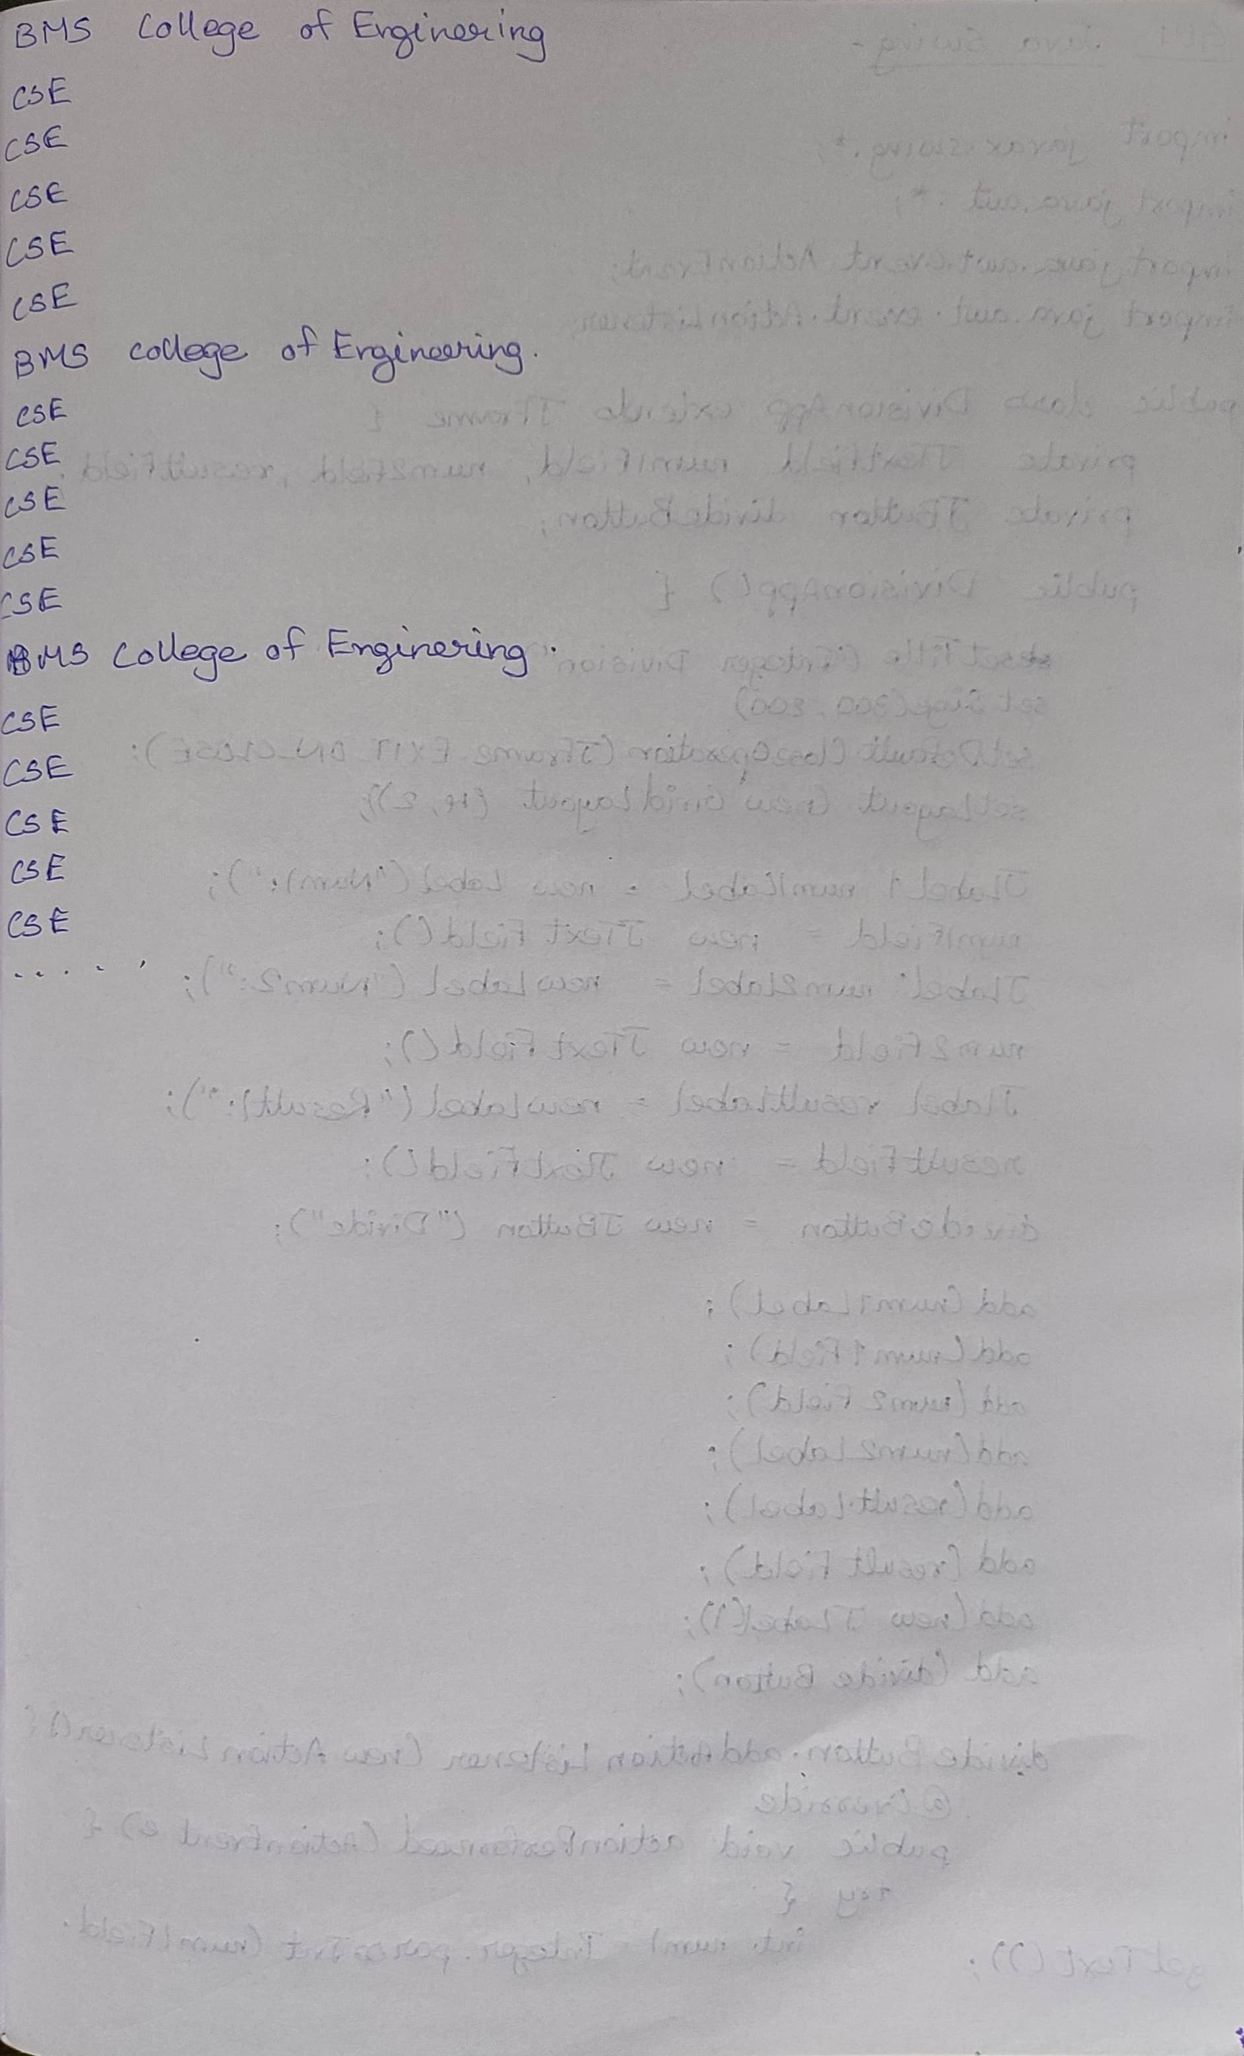

Code:

class DisplayMessage extends Thread {

private String message;

private int interval;

public DisplayMessage(String message, int interval) {

this.message = message;

this.interval = interval;

}

public void run() {

try {

while (true) {

System.out.println(message);

Thread.sleep(interval * 1000);

}

} catch (InterruptedException e) {

System.out.println("Thread interrupted: " + e.getMessage());

}

}

}

public class MultithreadingDemo {

public static void main(String[] args) {

System.out.println("Darshan YG, 1BM23CS087");

Thread thread1 = new DisplayMessage("BMS College of Engineering", 10);

Thread thread2 = new DisplayMessage("CSE", 2);

thread1.start();

thread2.start();

}

}

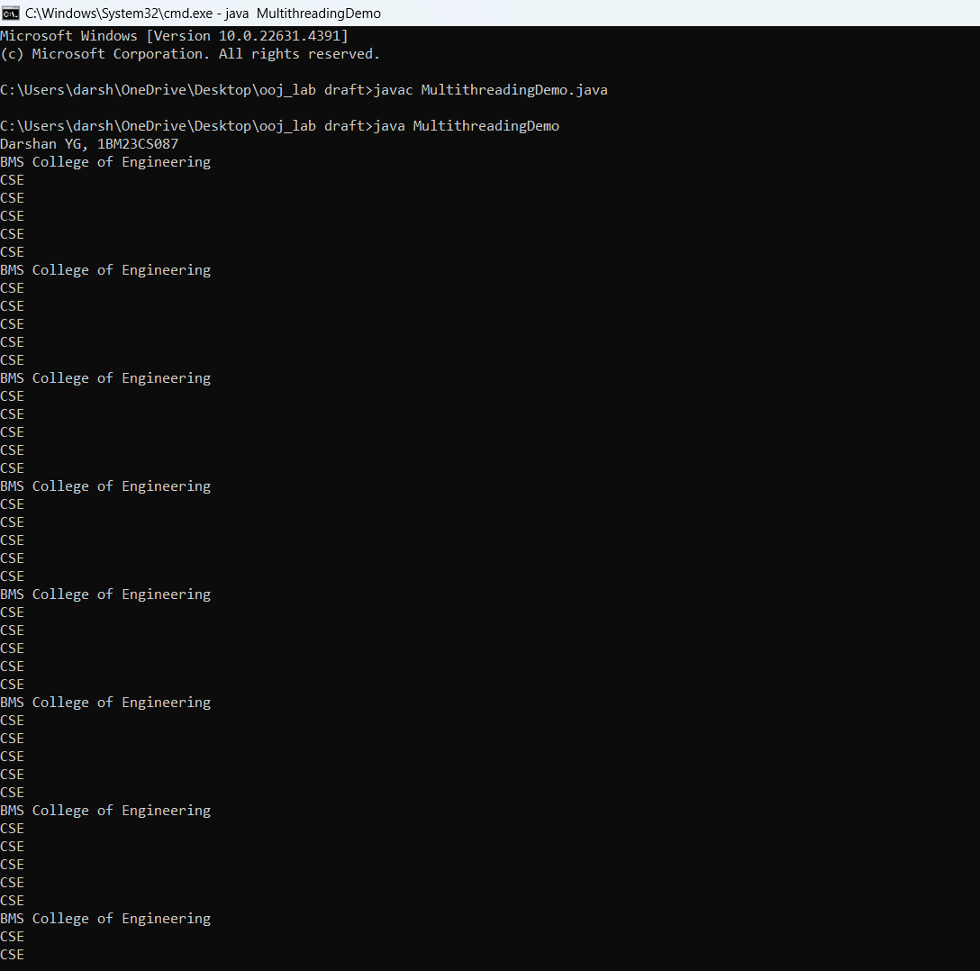

GUI Java Swing

Algorithm:

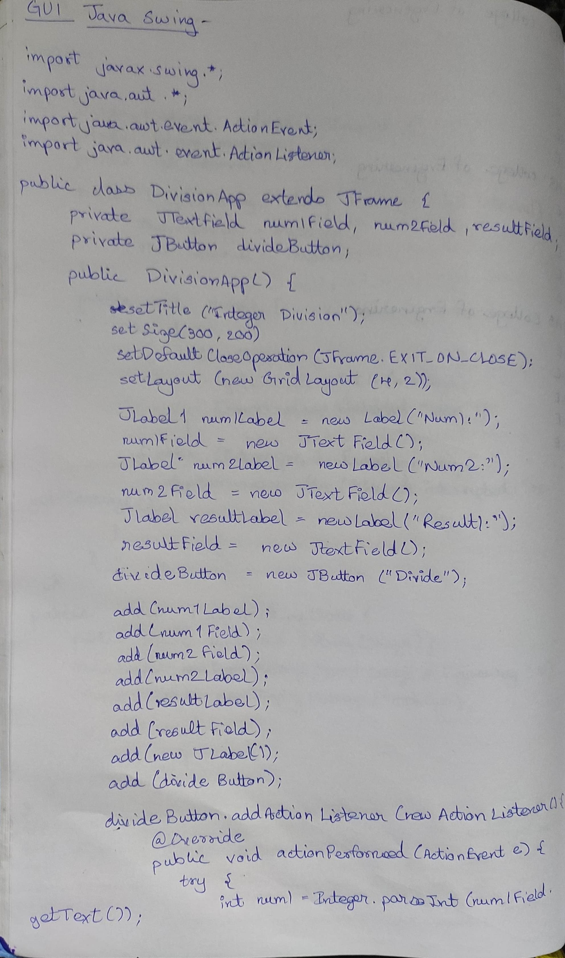

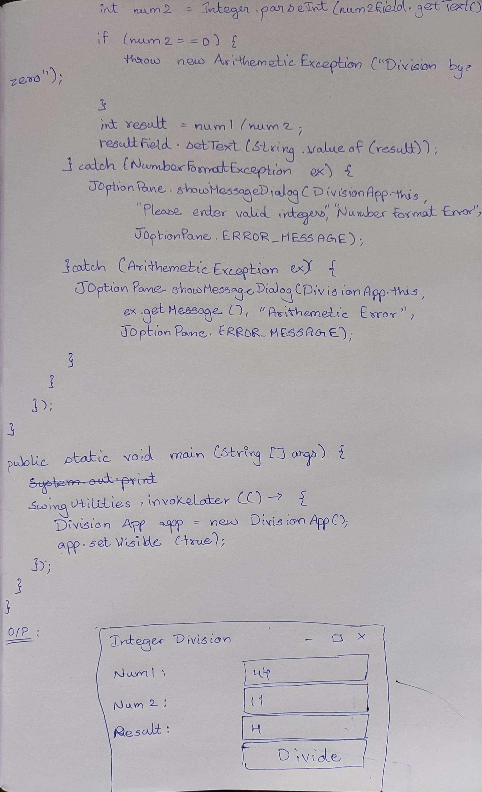

Code:

import javax.swing.*;

import java.awt.*;

import java.awt.event.ActionEvent;

import java.awt.event.ActionListener;

public class DivisionApp extends JFrame {

private JTextField num1Field, num2Field, resultField;

private JButton divideButton;

public DivisionApp() {

setTitle("Integer Division");

setSize(300, 200);

setDefaultCloseOperation(JFrame.EXIT_ON_CLOSE);

setLayout(new GridLayout(4, 2));

JLabel num1Label = new JLabel("Num1:");

num1Field = new JTextField();

JLabel num2Label = new JLabel("Num2:");

num2Field = new JTextField();

JLabel resultLabel = new JLabel("Result:");

resultField = new JTextField();

resultField.setEditable(false);

divideButton = new JButton("Divide");

add(num1Label);

add(num1Field);

add(num2Label);

add(num2Field);

add(resultLabel);

add(resultField);

add(new JLabel());

add(divideButton);

divideButton.addActionListener(new ActionListener() {

@Override

public void actionPerformed(ActionEvent e) {

try {

int num1 = Integer.parseInt(num1Field.getText());

int num2 = Integer.parseInt(num2Field.getText());

if (num2 == 0) {

throw new ArithmeticException("Division by zero");

}

int result = num1 / num2;

resultField.setText(String.valueOf(result));

} catch (NumberFormatException ex) {

JOptionPane.showMessageDialog(DivisionApp.this,

"Please enter valid integers.", "Number Format Error",

JOptionPane.ERROR_MESSAGE);

} catch (ArithmeticException ex) {

JOptionPane.showMessageDialog(DivisionApp.this,

ex.getMessage(), "Arithmetic Error",

JOptionPane.ERROR_MESSAGE);

}

}

});

}

public static void main(String[] args) {

System.out.println("Darshan YG, 1BM23CS087");

SwingUtilities.invokeLater(() -> {

DivisionApp app = new DivisionApp();

app.setVisible(true);

});

}

}

